JST Computer Science and Technology Promotion Program
"The Development of Space Simulation Net-Laboratory System"

How to Use VRML
（Using the Fortran）

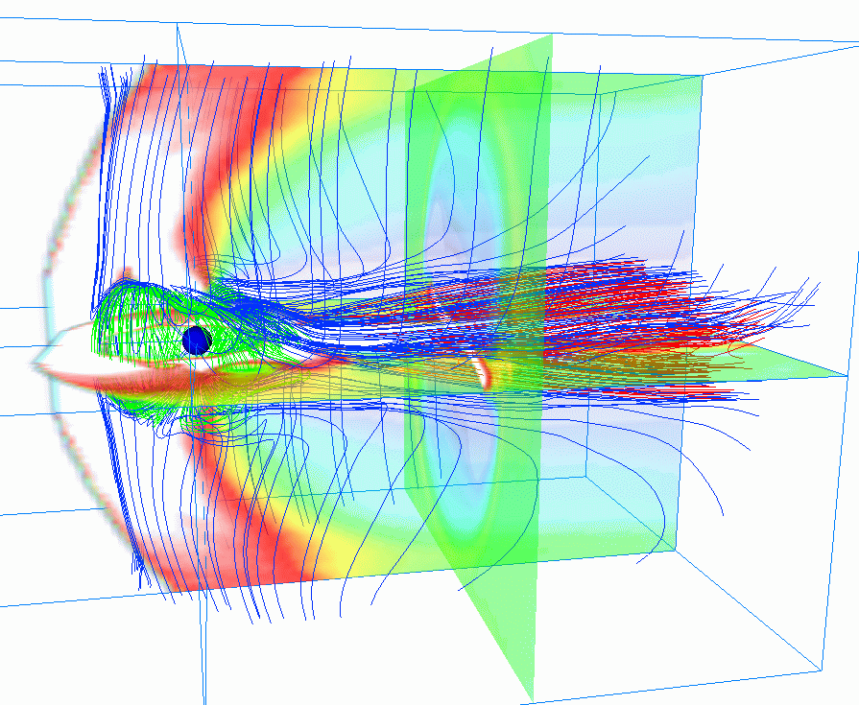

March, 2003
Solar-Terrestrial Environment Laboratory, Nagoya University
Tatsuki Ogino

JST Computer Science and Technology Promotion Program
"The Development of Space Simulation Net-Laboratory System"

How to Use VRML
（Using the Fortran）

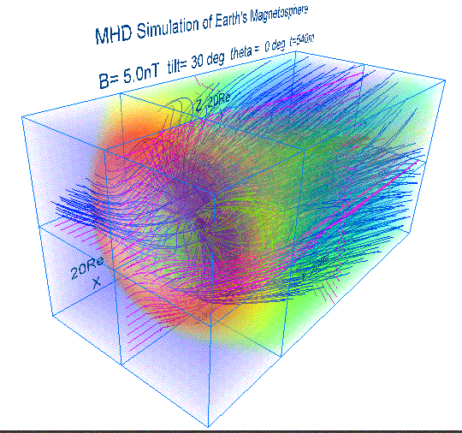

March, 2003
Solar-Terrestrial Environment Laboratory, Nagoya University
Tatsuki Ogino

JST Computer Science and Technology Promotion Program
"The Development of Space Simulation Net-Laboratory System"

How to Use VRML
（Using the Fortran）

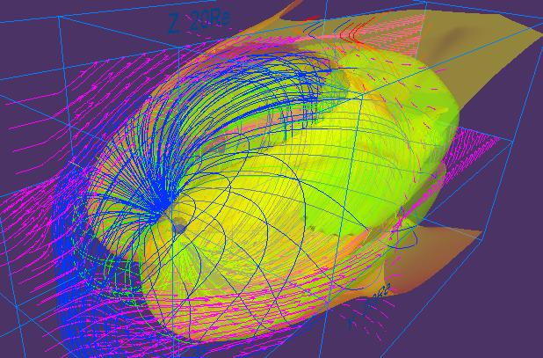

March, 2003
Solar-Terrestrial Environment Laboratory, Nagoya University
Tatsuki Ogino

JST Computer Science and Technology Promotion Program
"The Development of Space Simulation Net-Laboratory System"

How to use VRML
（Using the Fortran）



March, 2003
Solar-Terrestrial Environment Laboratory, Nagoya University
Tatsuki Ogino

Index
Purpose 1
Content 1
1. Fundamental example (1) 4
1-1. Cube 5
1-2. Rectangular parallelepiped 6
1-3. Trigonal pyramid 7
1-4. Column 8
1-5. Sphere 9
1-6. Background color 10
1-7. Character string 11
1-8. Polygonal line : monochrome 12
1-9. Polygonal line : gradation 13
1-10. Dotted line : monochrome 14
1-11. Dotted line : gradation 15
1-12. Arrow with the thickness 16
1-13. Curve with the thickness 17
1-14. Plane (1) : Monochromatic triangular mesh 18
1-15. Plane (2) : Triangular belt 19
1-16. Plane (3) : Polychrome triangular mesh 20
1-17. Solid : It is composed of the triangular mesh 21
1-18. Texture mapping 22
1-19. The complicated curved surface : Triangular mesh 23
2. Fundamental example (2) 24
2-1. Character 25
2-2. Point 26
2-3. Line 27
2-4. Triangular mesh 28
2-5. Pixel image 29
2-6. Frame and pixel image and character 30
2-7. Equivalence plane 31
2-8. Outer magnetosphere by three-dimensional lattice 32
2-9. Inner magnetosphere by three-dimensional lattice 33
2-10. Ionosphere by three-dimensional lattice 34
2-11. Unification of outer / inner magnetosphere and inosphere 35
3. Application to the MHD simulation 36
3-1. Sectional views such as plasma temperature of the earth's magnetosphere are drew by the pixel image 37
<The pixel image using maximum value and minimum value> 37
3-2. Three-dimensional structure of the earth's magnetosphere 39
<The decision by beforehand describing line of magnetic force> 39
<Three-dimensional line of magnetic force starting from polar region> 40
<Three-dimensional line of magnetic force starting from equatorial plane> 41
<The test of the boundary in the closed region with that it opens> 42
3-3. The synthesis of the three-dimensional image of pixel image and line of magnetic force 43
3-4. Three dimensional distribution of the plasma temperature in the whole earth’s magnetosphere drawn by the multiple pixel image planes 44
4. 3-Dimensional MHD Simulation of Earth's Magnetosphere 46
5. Visualization to Various 3-Dimensional MHD Models of Earth's Magnetosphere (English) 51
5-a. Half volume model of earth’s magnetosphere with IMF By and Bz components 52
5-b. Quarter volume model of earth’s magnetosphere 54
5-c. Half volume model of earth’s magnetosphere with dipole tilt 57
5-d. Whole volume model of earth’s magnetosphere 59
６．Application of VRML to 3-Dimensional MHD Models of Earth's Magnetosphere (English) 61
6-a. 3-dimensional visualization of earth’s magnetosphere with multiple planes 61
6-b. 3-dimensional visualization of earth’s magnetosphere with equivalence planes 63
6-c. Cropping of 3-dimensional data 65
References 66
Fortran program and image file list 67

Purpose

The three-dimensional visualization is indispensable in order to understand three-dimensional simulation results such as the earth's magnetosphere better. By the appearance of the VRML (Virtual Reality Modeling Language) which is the international and standard language for the internet's three-dimensional visualization, it would be possible to watch the three-dimensional image as VRML file by the VRML viewer, even if people does not have three-dimensional image processing machinery and three-dimensional image processing software. However, utilization and popularization of the VRML do not advance very much in present state, because that there is no a convenient tool which makes the VRML file and that it is not easy to make the complicated VRML file.

From the viewpoint of the method for visualizing three-dimensional simulation result of the magnetosphere according to the VRML, we have wrestled in making the VRML file earlier by utilizing experience and knowledge cultivated for a long time for the image processing using Fortran and C language. In the computer science and technology project as the extension, we have made this manual "How to Use VRML" for the purpose of the three-dimensional visualization of the simulation utilizing by presenting interface subroutine package for the VRML contents preparation according to Fortran and C language, and offering to the project participants by advancing development and standardization of the visualization tool.

Content

Three-dimensional visualization is necessary in order to know what it has obtained in the three-dimensional and global MHD simulation of the solar wind and earth's magnetosphere interaction. For example, to make the moving image by the rotation of coordinate axis is a method for using well in order to understand three-dimensional lines of magnetic force structure, etc.. Though three-dimensional visualization tools such as AVS of the marketing, etc. are not always conveniently worthwhile, the thing leaves the three-dimensional image display the part which is not sufficient at any cost, when it intends to describe the figure really described, because it is too rich in a diversity. In such case, basic program of the image processing will be composed. We have carried out this by using three-dimensional graphics machinery TITAN and Indigo-2 and three-dimensional graphics software Dore, AVS, Open-GL. Using three-dimensional image processing function of Z buffers of the special-purpose machinery, etc., by rotating the object immediately, and doing the scaling line of magnetic force is described in the three dimensional space, and by choosing and seeable viewpoint, it has been utilized for the understanding of the three-dimensional structure.

However, the situation has completely changed by appearance of the VRML, that is, it is not necessary for the three-dimensional image processing to have three-dimensional graphics machinery and three-dimensional image processing software. The speed of the three-dimensional image processing (rotation, scaling, etc.) is decided with the dependence on the ability of the computer, and viewers such as Cosmo Player of the VRML2.0 correspondence have standardly been added, if browsers such as recent Netscape and Internet Explorer are used. The personal computer became also recently high-speed, and the performance which is not inferior to Indigo-2 made by SGI, etc. can be demonstrated, if high-speed cpu and graphic accelerator are piled, and if the more and more sufficient memory (over 128 MB) is put. And, we can comfortably observe the three-dimensional image with the high accuracy by using Webspace and Cosmo Worlds of SGI.

How the preparation of the VRML file is realized, is described in the following. We prepare the Fortran Interface Subroutine Package for the VRML file preparation, and VRML file (*.wrl) is directly made from three-dimensional simulation data using the Fortran program. Though there is a difference between two-dimension and three-dimension, this method is similar to the method for making the PostScript image file. In the viewer of the VRML, there generally "walk mode" and "examine mode". The walk mode moves the viewpoint, and the examine mode does transfer and rotation and scaling of the object. It is possible to examine more apparently the three-dimensional structure of the magnetosphere in this way. Present important problem is for the VRML files to grow with several MB very much, since VRML file of the three-dimensional line of magnetic force drawing of the earth's magnetosphere uses the ascii file. By using the VRML binary file or compression of the ascii VRML file, it is also expected that it is considerably improved this problem. It is future most interesting problem to display the three-dimensional moving image of time change of the earth's magnetosphere with the change of IMF in the VRML, namely a real three-dimensional animation movie.

This "How to use VRML" includes the following content. In chapter 1, chapter 2, the fundamental examples which makes the three-dimensional image file of the VRML2.0 type by using the Fortran program, and examples which can be utilized as it is for the analysis of simulation result are shown. In addition, the specific example in applying to the MHD simulation result of solar wind and earth's magnetosphere interaction is shown in chapter 3. In chapter 4 is shown a series of specific example which demonstrated how image analysis in the three-dimensional global MHD simulation and the image processing by Postscript and VRML in the earth's magnetosphere are executed. In final chapters 5 and 6 are shown practical VRML examples for visualization of the earth’s magnetosphere simulated by various 3-dimensional MHD models. And, CD-ROM is putting all main Fortran programs and subroutine packages shown in this manual as a source program format. We are happy if it is useful for the computer science and technology program participants.

1. Fundamental example (1)

In this chapter, the fundamental example which makes the image file of the VRML2.0 type using the Fortran program is shown. Concretely, the image file of the VRML2.0 type is made by compiling, linking and executing each main program and subroutine package.

Usage:
1. f77 -c -O pk1subrtn.f
The object module (pk1subrtn.o) is made by the compilation of subroutine package (pk1subrtn.f).
2. f77 -O box1.f pk1subrtn.o
The execution file (a.out) is made by the link of the main program (box1.f etc.) with the object module (pk1subrtn.o).
3. a.out
The VRML 2.0 (fort.10) file is made by the execution of the execution file (a.out).
4. mv fort.10 box1.wrl
The file name of made VRML is changed at "***.wrl".

1-1. Cube

main program box1.f
subroutine box1 (r, g, b, sz)

Description: This program draws a cube by giving the color value and the length of one side.

Input variable:
r : The red value [0,1]
g : The green value [0,1]
b : The blue value [0,1]
sz : The length of one side of the cube

Drawing example: box1.wrl
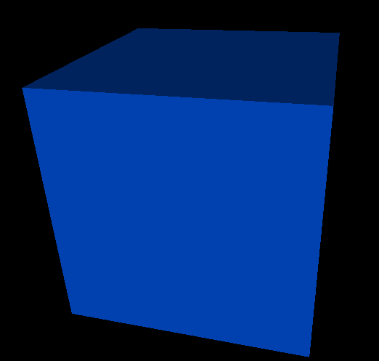

1-2. Rectangular parallelepiped

main program box2.f
subroutine box2 (r, g, b, sx, sy, sz)

Description: This program draws a rectangular parallelepiped by giving the color value and the length of three edges.

Input variable:
r : The red value [0,1]
g : The green value [0,1]
b : The blue value [0,1]
sx : The length of one side of the x direction
sy : The length of one side of the y direction
sz : The length of one side of the z direction

Drawing example: box2.wrl


1-3. Trigonal pyramid

main program cone1.f
subroutine cone1k1 (rd, h, r, g, b, x, y, z)

Description: This program draws the trigonal pyramid by giving the color value and the radius of the basal plane, the height.

Input variable:
rd : The radius of the basal plane
h : The height
r : The red value [0,1]
g : The green value [0,1]
b : The blue value [0,1]
x : Parallel translation quantity of the x direction
y : Parallel translation quantity of the y direction
z : Parallel translation quantity of the z direction

Drawing example: cone1.wrl


1-4. Column

main program cylinder1.f
subroutine cylinder1(rd, h, r, g, b)

Description: This program draws a column that it gives value of the color and radius of the basal plane, the height.

Input variable:
rd : The radius of the basal plane
h : The height
r : The red value [0,1]
g : The green value [0,1]
b : The blue value [0,1]

Drawing example: cylinder1.wrl


1-5. Sphere

main program sphere1.f
subroutine shere2 (r, g, b, rd)

Description: This program draws a sphere that it gives value of the color and radius.

Input variable:
rd : The radius
r : The red value [0,1]
g : The green value [0,1]
b : The blue value [0,1]

Drawing example: sphere1.wrl
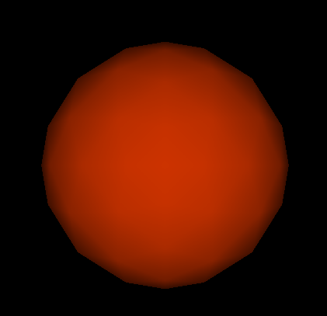

1-6. Background color

main program backgrd4.f
subroutine backd (n1, n2, rd)

Description: This program gives the color to the background.

Input variable:
n1 : The number of the step in which the color of the ground changes
n2 : The number of the step in which the sky of the ground changes
rd : The angle per one step
Drawing example: backgrd4.wrl


1-7. Character string

main program text1.f
subroutine text1 (x, y, z, n, r, g, b, sz, ch1)

Description: This program draws character string that it gives character string and font color, font size.

Input variable:
x : Parallel translation quantity of the x direction
y : Parallel translation quantity of the y direction
z : Parallel translation quantity of the z direction
n : The number of the character string (maximum is 10)
r : The red value [0,1]
g : The green value [0,1]
b : The blue value [0,1]
sz : The font size
ch1 : The input character string [ within 40 characters ]

Drawing example: text1.wrl


1-8. Polygonal line : monochrome

main program lineset1.f
subroutine line1 (ln, po, r, g, b)

Description: This program draws a polygonal line in giving double end coordinate and color of the segment, and in connecting the coordinate in one stroke in the order.

Input variable:
ln : The data number.
po(3*ln) : The coordinate of the point (x, y, z) is given in the order.
r : The red value. [0,1]
g : The green value. [0,1]
b : The blue value. [0,1]
Drawing example: lineset1.wrl
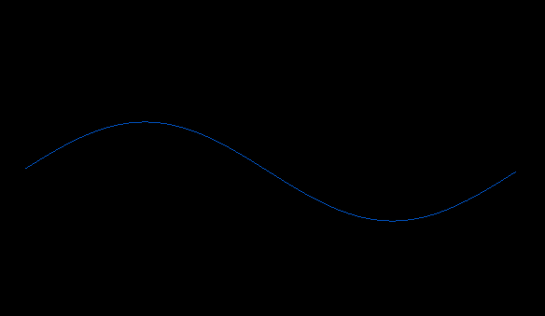

1-9. Polygonal line : gradation

main program lineset2.f
subroutine line2 (ln, po, sco, eco)

Description: This program draws a polygonal line in giving double end coordinate and color ( gradation ) of the segment, and in connecting the coordinate in one stroke in the order.

Input variable:
ln : The data number
po(3*ln) : The coordinate of the point (x, y, z) is given in the order
sco : The color in the start of the gradation (color code)
eco : The color in the end of the gradation (color code)
color code (1: white 2: yellow 3: mazenda 4: red 5: sian 6: green 7: blue )

Drawing example: lineset2.wrl
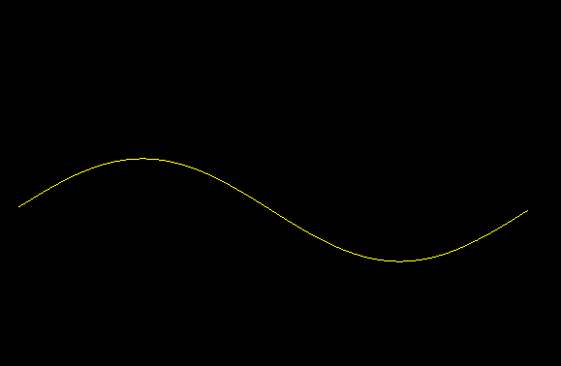

1-10. Dotted line : monochrome

main program pointset1.f
subroutine point1 (ln, po, r, g, b)

Description: This program draws dotted line that it gives the coordinate of the point.

Input variable:
ln : The data number
po(3*ln) : The coordinate of the point (x, y, z) is given in the order
r : The red value [0,1]
g : The green value [0,1]
b : The blue value [0,1]

Drawing example: pointset1.wrl
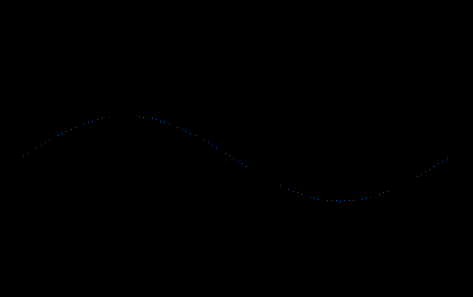

1-11. Dotted line : gradation

main program pointset2.f
subroutine point2 (ln, po, sco, eco)

Description: This program draws dotted line that it gives the coordinate of the point.

Input variable:
ln : The data number
po(3*ln) : The coordinate of the point (x, y, z) is given in the order
sco : The color in the start of the gradation (color code)
eco : The color in the end of the gradation (color code)
color code (1: white 2: yellow 3: mazenda 4: red 5: sian 6: green 7: blue )

Drawing example: pointset2.wrl
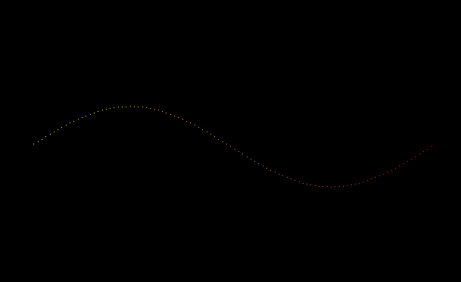

1-12. Arrow with the thickness

main program arrow2.f
subroutine arrow2 (nx, ny, u, p, rd1, rd2, h, cx, cy, cz, br, bg, bb, cr, cg, cb)

Description: This program draws an arrow with the thickness by combining the cylinder (gradation color) with the trigonal pyramid.

Input variable:
nx : Data number of the x direction
ny : Data number of the y direction
u : Color (r, g, b) of the point is given in the order
p : The coordinate of the point (x, y, z) is given in the order
rd1 : The radius of the cylindrical basal plane
rd2 : The radius of the basal plane of trigonal pyramid
h : The height of the trigonal pyramid
cx : The central x coordinate of the trigonal pyramid
cy : The central y coordinate of the trigonal pyramid
cz : The central z coordinate of the trigonal pyramid
br : The red value of the cylinder basal plane [0,1]
bg : The green value of the cylinder basal plane [0,1]
bb : The blue value of the cylinder basal plane [0,1]
cr : The red value of the trigonal pyramid [0,1]
cg : The green value of the trigonal pyramid [0,1]
cb : The blue value of the trigonal pyramid [0,1]

Drawing example: arrow2.wrl


1-13. Curve with the thickness

main program linemesh1.f
subroutine linemesh (p, n1, rd, r, g, b)

Description: This program draws a line with the thickness by connecting cylinder.

Input variable:
p : The coordinate of the point (x, y, z) is given in the order
n1 : The data number
rd : The radius of the cylinder
r : The red value of the cylinder [0,1]
g : The green value of the cylinder [0,1]
b : The blue value of the cylinder [0,1]

Drawing example: linemesh1.wrl
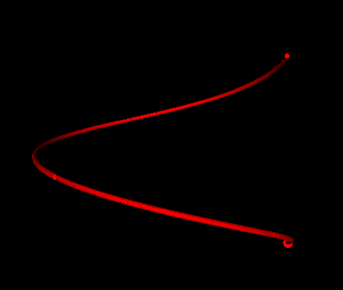

1-14. Plane (1) : Monochromatic triangular mesh

main program mesh1.f
subroutine face1 (ln, po, r, g, b)

Description: This program draws a plane by triangular mesh that it gives the coordinate of the point and.

Input variable:
ln : The data number
po : The coordinate of the point (x, y, z) is given in the order
r : The red value of the plane [0,1]
g : The green value of the plane [0,1]
b : The blue value of the plane [0,1]

Drawing example: mesh1.wrl


1-15. Plane (2) : Triangular belt

main program triangb1.f
subroutine triangbk1 (nx, ny, u, p)

Description: This program draws a plane by the triangular belt that it gives coordinate of point data and color.

Input variable:
nx : Data number of the x direction
ny : Data number of the y direction
u : Color (r, g, b) of the point is given in the order
p : The coordinate of the point (x, y, z) is given in the order

Drawing example: triangb1.wrl
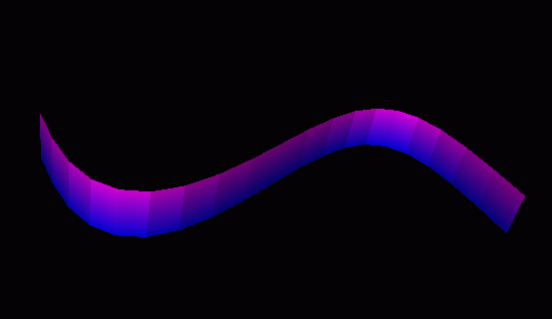

1-16. Plane (3) : Polychrome triangular mesh

main program triangm1.f
subroutine triangm (nx, ny, u, p)

Description: This program draws a plane by the triangular mesh that it gives coordinate of point data and color.

Input variable:
nx : Data number of the x direction
ny : Data number of the y direction
u : Color (r, g, b) of the point is given in the order
p : The coordinate of the point (x, y, z) is given in the order

Drawing example: triangm1.wrl
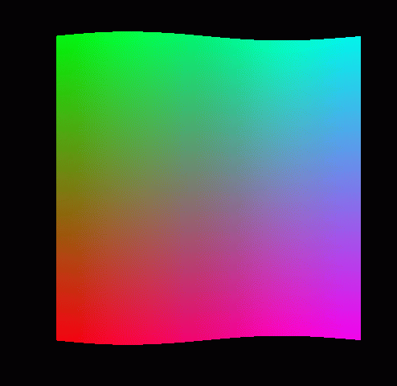

1-17. Solid : It is composed of the triangular mesh

main program defusem1.f
subroutine defusem (nx, ny, u, p, x1, y1, z1, x2, y2, z2, r, n)

Description: This program draws a solid by the plane made from the data of the point by the triangular mesh gradually moving.

Input variable:
nx : Data number of the x direction
ny : Data number of the y direction
u : Color (r, g, b) of the point is given in the order
p : The coordinate of the point (x, y, z) is given in the order
x1 : Parallel translation quantity of the x direction
y1 : Parallel translation quantity of the y direction
z1 : Parallel translation quantity of the z direction
x2 : x coordinate of the rotating shaft
y2 : y coordinate of the rotating shaft
z2 : z coordinate of the rotating shaft
r : The transfer rotation angle ( radian )
n : The processing frequency

Drawing example: defusem1.wrl
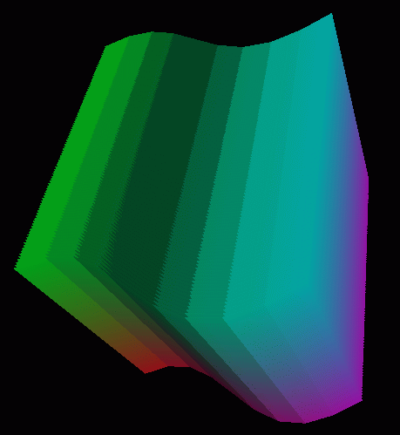

1-18. Texture mapping

main program image1.f
subroutine imagetx1 (ln, po, ch1, n)

Description: This program sticks a textured image designated for the plane drew by the triangular mesh.

Input variable:
ln : The data number.
po : The coordinate of the point (x, y, z) is given in the order.
ch1 : The URL of the textured image.
n : The number of characters of the URL.

Drawing example: image1.wrl


1-19. The complicated curved surface : Triangular mesh

main program ebmesh3d.f
subroutine triangm1(nx, ny, u, p)

Description: This program is draws a picture by the triangular mesh it reads the point data of constituting the plane.

Input variable:
nx : Data number of the x direction
ny : Data number of the y direction
u : Color (r, g, b) of the point is given in the order
p : The coordinate of the point (x, y, z) is given in the order

Drawing example: ebmesh3d.wrl
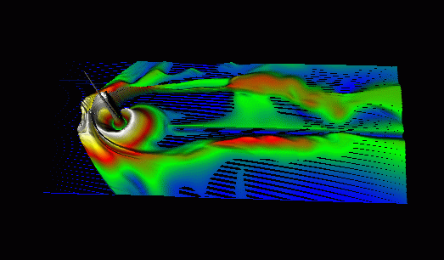

2. Fundamental example (2)

In this chapter, the example that it is fundamental for making the image file of the VRML 2.0 type using the Fortran program and can utilize as it is for analysis application of simulation data is shown. Concretely, the image file of the VRML2.0 type is made by compiling, linking and executing each main program and subroutine package (zvrsuba.f).

The usage:
1. f77 -c -O zvrsuba.f
The object module (zvrsuba.f) is made by the compilation of subroutine package (zvrsuba.o).
2. f77 -O msymbol.f zvrsuba.o
The execution file (a.out) is made by the link of the main program (msymbol.f etc.) with the object module (zvrsuba.o).
3. a.out
The VRML 2.0 (fort.10) file is made by the execution of the execution file (a.out).
4. mv fort.10 box1.wrl
The file name of made VRML is changed at "***.wrl".

2-1. Character

main program msymbol.f
subroutine symblv (x, y, z, h, chr, n) …white
symblvc (x, y, z, h, r, g, b, chr, n) …multicolor
Description: This program draws characters by giving width and height (, color) of character and origin, character.

Input variable:
x : The x coordinate of the origin
y : The y coordinate of the origin
z : The z coordinate of the origin
h : The height of the character
r : The red value [0,1]
g : The green value [0,1]
b : The blue value [0,1]
chr : The input character [ within 80 characters ]
n : The number of the character

Drawing example: msymbol.wrl
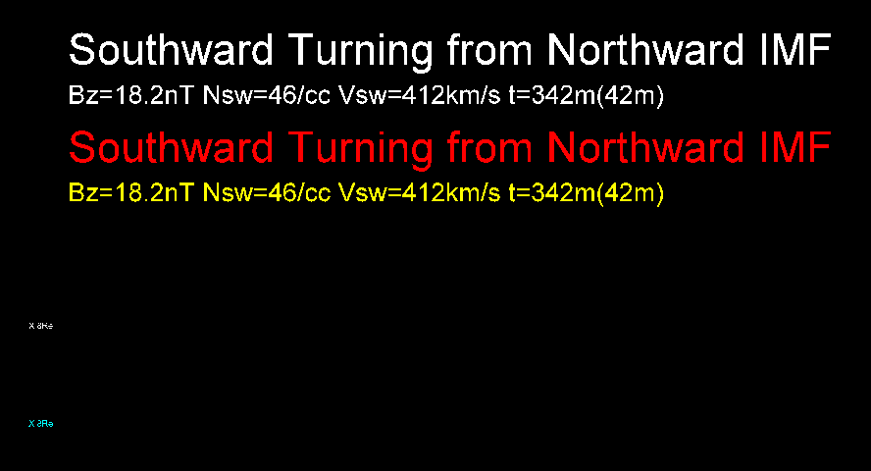

2-2. Point

main program mpoint.f
subroutine point3d (nx, ny, nz, x0, y0, z0, xl, yl, zl, ico, u)

Description: This program draws points by giving position and colored code of the three-dimensional point of the nx*ny*nz piece.

Input variable:
nx : Data number of the x direction
ny : Data number of the y direction
nz : Data number of the z direction
x0 : The x coordinate of the origin
y0 : The y coordinate of the origin
z0 : The z coordinate of the origin
x1 : The length of the x direction
y1 : The length of the y direction
z1 : The length of the z direction
ico : color code [1,7]
u (nx*ny*nz) : They are input data, and the coordinate of
the multipoint (x, y, z) is given in the order

Drawing example: mpoint.wrl
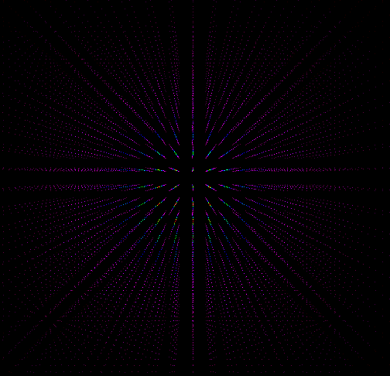

2-3. Line

main program mline.f
subroutine line3d (lasl, r, g, b, po)

Description: This program draws a line in giving coordinate and color of sequence of points, and in connecting sequence of points in the one stroke.

Input variable:
lasl : The number of sequence of points
r : The red value [0,1]
g : The green value [0,1]
b : The blue value [0,1]
po (3*lasl) : The coordinate of sequence of points (x, y, z) is given in the order

Drawing example: mline.wrl
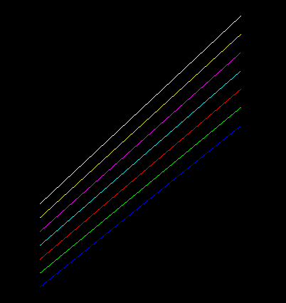

2-4. Triangular mesh

main program mtriangm.f
subroutine triangm (nx, ny, u, p)

Description: This program draws the image of the two-dimensional data of the coordinate of the nx*ny piece by giving position in the origin and length of one side, data number, colored code by the triangular mesh.

Input variable:
nx : Data number of the x direction
ny : Data number of the y direction
u (3*nx*ny) : Input data
p (3*nx*ny) : Auxiliary data necessary for the calculation

Drawing example: mtriangm.wrl
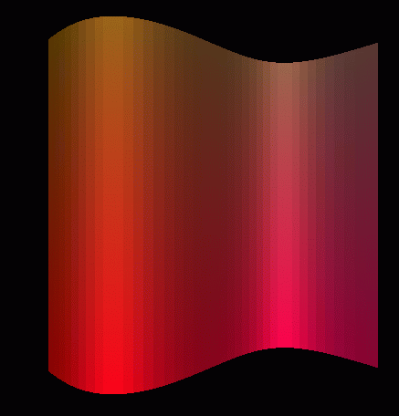

2-5. Pixel image

main program mzpt03.f
subroutine pixel2(nx, ny, xb, yb, x1, y1, ipx0, ico, icc, zcc, u)

Description: This program draws a image of the two-dimensional data u (nx*ny) by giving position in the origin and length of one side, data number, colored code in the pixel image.

Input variable:
nx : Data number of the x direction
ny : Data number of the y direction
xb : The x coordinate of the origin
yb : The y coordinate of the origin
xl : The length of the x direction
yl : The length of the y direction
ipx0 : 3=rgb color, 4=rgb color and transparency can be set
ico : color code [1,7]
icc : Picture is drawn in the 1=xy plane, 2=xz plane, 3=yz plane
zcc : The position in chosen plane
u (nx*ny) : Input data

Drawing example: mzpt03.wrl
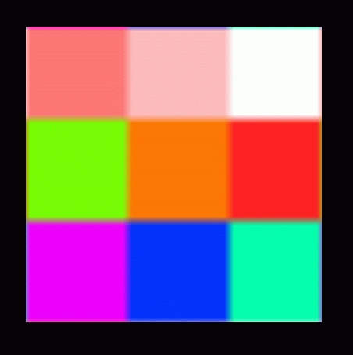

2-6. Frame and pixel image and character

main program mpix015.f

Description: This program draws picture by combining frame and pixel image and character.

Input variable: x, y, z, h, ch1, n, icc, zcc, r, g, b, x1, y1, x2, y2, nx, ny, xb, yb, x1, y1, ipx0, ico, u
It is well-informed the each subroutine reference.

Using subroutine :
symblv (x, y, z, h, ch1, n) :
rect1 (icc, zcc, r, g, b, x1, y1, x2, y2) :
pixel2 (nx, ny, xb, yb, x1, y1, ipx0, ico, icc zcc, u) :

Drawing example: mpix015.wrl
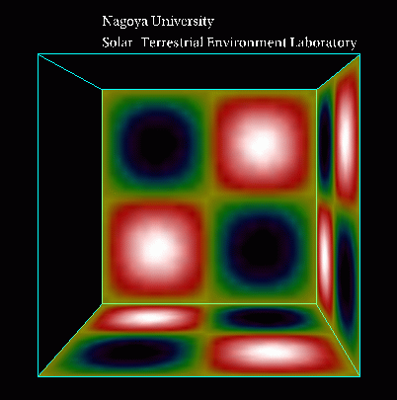

2-7. Equivalence plane

main program mcube301.f
subroutine csuba (ic, aa, u) < (nx, ny, nz, x0, y0, z0, xl, yl, zl, nol, ico)

Description: This program draws equivalence plane by giving and three-dimensional data (u (nx*ny*nz)).

Input variable:
nx = ic (2) : Data number of the x direction
ny = ic (3) : Data number of the y direction
nz = ic (4) : Data number of the z direction
x0 = aa (11) : The x coordinate of the origin
y0 = aa (12) : The y coordinate of the origin
z0 = aa (13) : The z coordinate of the origin
xl = aa (8) : The length of the x direction
yl = aa (9) : The length of the x direction
zl = aa (10) : The length of the x direction
ico = ic (1) : color code [1,7]
nol : The number of the edge of the rectangular parallelepiped ;12
u (nx*ny*nz) : Three-dimensional input data

Drawing example: mcube301.wrl
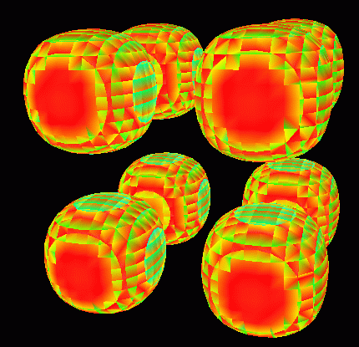

2-8. Outer magnetosphere by three-dimensional lattice

main program outline3d.f
subroutine lat3d1 ( ic, aa ) < ( nx, ny, nz, xl, yl, zl, r, g, b )

Description: This program draws the outer magnetosphere by three-dimensional lattice.

Input variable:
nx = ic(1) : Data number of the x direction
ny = ic(2) : Data number of the y direction
nz = ic(3) : Data number of the z direction
xl = aa(1) : The length of the x direction
yl = aa(2) : The length of the x direction
zl = aa(3) : The length of the x direction
r = aa(4) : The red value [ 0,1 ]
g = aa(5) : The green value [ 0,1 ]
b = aa(6) : The blue value [ 0,1 ]

Drawing example: outline3d.wrl
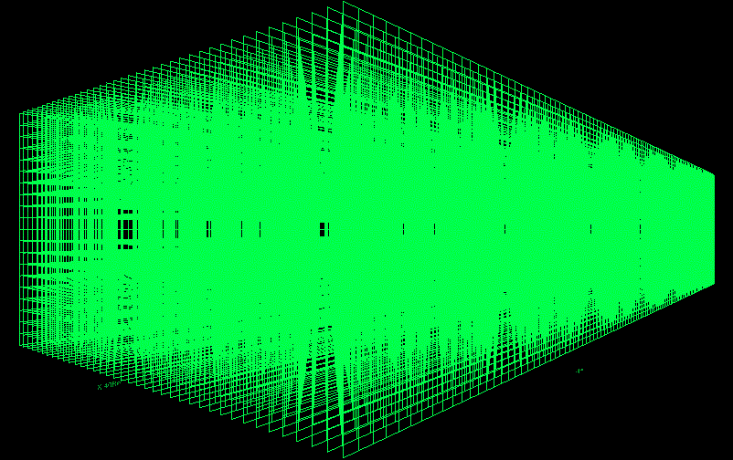

2-9. Inner magnetosphere by three-dimensional lattice

main program outline3d.f
subroutine lat3d2 ( ic, aa ) < (nx, ny, nz, xl, yl, zl, r, g, b)

Description: This program draws the inner magnetosphere by three-dimensional lattice.

Input variable:
nx = ic(1) : Data number of the x direction
ny = ic(2) : Data number of the y direction
nz = ic(3) : Data number of the z direction
xl = aa(1) : The length of the x direction
yl = aa(2) : The length of the x direction
zl = aa(3) : The length of the x direction
r = aa(4) : The red value [ 0,1 ]
g = aa(5) : The green value [ 0,1 ]
b = aa(6) : The blue value [ 0,1 ]

Drawing example: inline3d.wrl
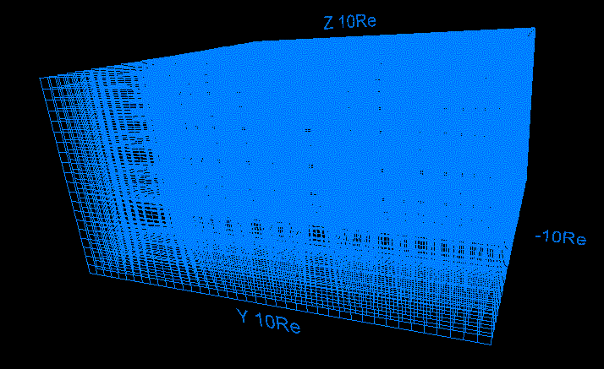

2-10. Ionosphere by three-dimensional lattice

main program denline3d.f
subroutine lat3d3 ( ic, aa ) < ( re1, re2, r, g, b )

Description: This program draws the ionosphere by three-dimensional lattice.

Input variable:
re1 = aa(1) : The radius of inner circle
re2 = aa(2) : The radius of outer circle
r = aa(3) : The red value [ 0,1 ]
g = aa(4) : The green value [ 0,1 ]
b = aa(5) : The blue value [ 0,1 ]

Drawing example: denline3d.wrl
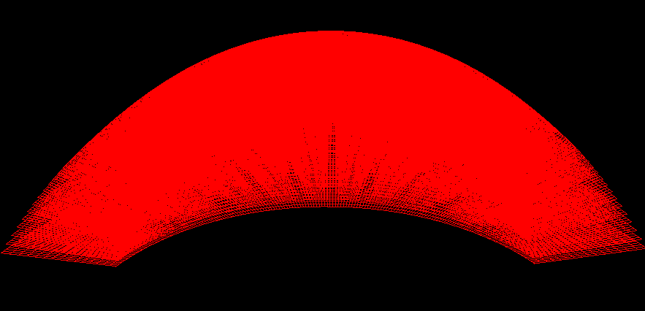

2-11. Unification of outer / inner magnetosphere and inosphere

cat outline3d.wrl inline3d.wrl denline3d.wrl > line3d.wrl

Drawing example: line3d.wrl
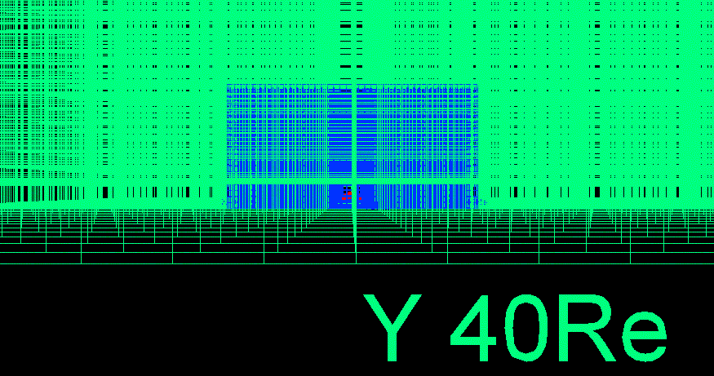

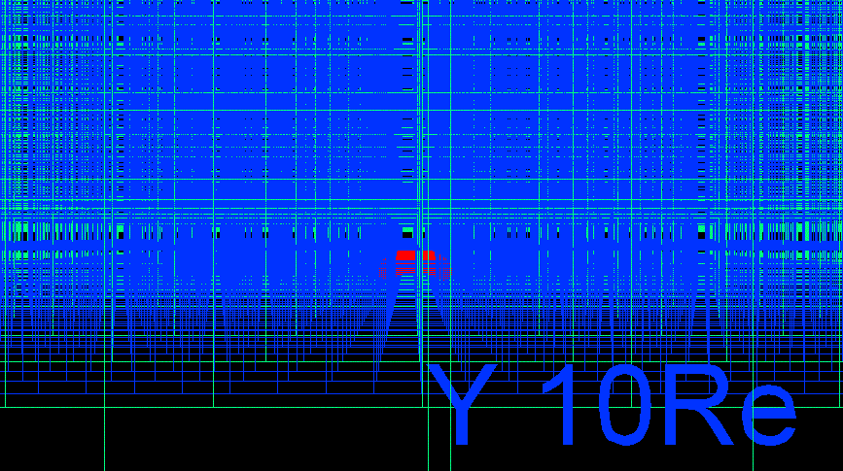

3. Application to the MHD simulation

In this chapter, the concrete application which makes the VRML file by using the asymmetrical three-dimensional magnetosphere data of the three-dimensional global MHD simulation of interaction between the solar wind and the earth's magnetosphere with dawn-dusk asymmetry, is shown.

The usage:
1. f77 -c -O zvrsuba.f
The object module (zvrsuba.f) is made by the compilation of subroutine package (zvrsuba.o).
2. f77 -O zvrcroa.f zvrsuba.o
The execution file (a.out) is made by the link of the main program (zvrcroa.f or zvrmaga.f) with the object module (zvrsuba.o).
3. a.out
The VRML 2.0 (fort.10) file is made by the execution of the execution file (a.out).
4. mv fort.10 box1.wrl
The file name of made VRML is changed at "***.wrl".
5. cat zvrcroa.wrl zvrmaga.wrl > zvr1.wrl
The file of two VRML is synthesized.

3-1. Sectional views such as plasma temperature of the earth's magnetosphere are drew by the pixel image

VRML file which describes sectional views such as plasma temperature of the earth's magnetosphere in the pixel image is made to the three-dimensional MHD simulation data with dawn-dusk asymmetry, in executing main program: zvrcroa.f and subroutine package: zvrsuba.f, is made.

Main using subroutine:
pixel1(nx,ny,xb,yb,xl,yl,ipx0,ico,icc,zcc,vmin,vmax,u)

3D MHD simulation code which receives the result. : eartha10.f

Drawing example: This drawing example is drew pixel image of the sectional view of the three-dimensional MHD simulation result of the earth's magnetosphere using the translucency method. : zvrcroa.wrl
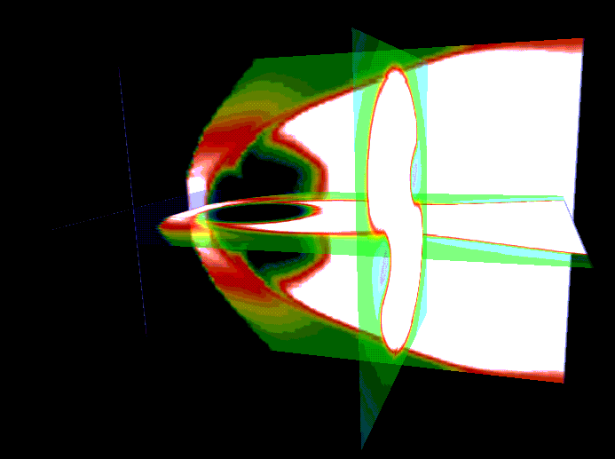
The details of main subroutine.

<The pixel image using maximum value and minimum value>
subroutine pixel1(nx,ny,xb,yb,xl,yl,ipx0,ico,icc,zcc,vmin,vmax,u)

Description: This program draws pixel image using maximum value (vmax) and minimum value (vmin) of u(i1) are given from the outside, u(i1) is normalized, and by giving position in the origin and length of one side, data number, colored code, the image of two-dimensional data u(nx*ny).
Input variable:
nx : Data number of the x direction
ny : Data number of the y direction
xb : The x coordinate of the origin
yb : The y coordinate of the origin
xl : The length of the x direction
yl : The length of the y direction
ipx0 : 3=rgb color, 4=rgb color and transparency can be set
ico : color code [1,7]
icc : Picture is drawn in the 1=xy plane, 2=xz plane, 3=yz plane
zcc : The position in chosen plane
u (nx*ny) : Input data
vmin : The maximum value of u(i1) given from the outside
vmax : The minimum value of u(i1) given from the outside
u (nx*ny) : Input data u(i1), i1=i+nx*(j-1)
Main using subroutine:
pixebe(nx,ny,ipx0) : The start of the pixel image
pixeco(nx,ny,ico,u) : The setting of the rgb color
pixect(nx,ny,ico,u) : The setting of transparency and rgb color
pixeen(xb,yb,xl,yl,icc,zcc) : The end of the pixel image

3-2. Three-dimensional structure of the earth's magnetosphere

This program draws the three-dimensional structure of line of magnetic force of the earth's magnetosphere in making to be inputting three-dimensional MHD simulation data with dawn-dusk asymmetry, in executing main program: zvrmaga.f and subroutine package: zvrsuba.f.

Main using subroutine:
ainte1a(ia,aa,f,p)
zsub33(ia,aa)
ainte1a(ia,aa,f,p)
ainte21(ia,aa,f,p)

MHD simulation code which receives the result.: eartha10.f

Drawing example: zvrmaga.wrl
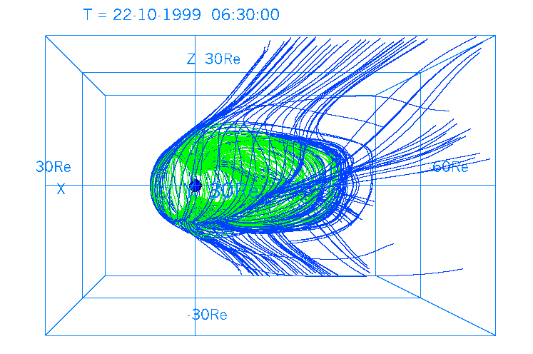
Details of main subroutine

<The decision by beforehand describing line of magnetic force>
subroutine ainte1a(ia,aa,f,p)

Description: Line of magnetic force is tracked by using magnetic field data of 3 components from three-dimensional MHD simulation data f(i1), closed, detached, line of magnetic force is judged.

Input variable:
nx=ia(1) : Data number of the x direction in the starting point of line of magnetic force
ny=ia(2) : Data number of the y direction in the starting point of line of magnetic force
mx=ia(3) : Data number of the x direction of three-dimensional data f(i1)
my=ia(4) : Data number of the y direction of three-dimensional data f(i1)
mz=ia(5) : Data number of the z direction of three-dimensional data f(i1)
nxz=ia(6) : The parameter which adjusts the global center
mi=ia(7) : The first position of the input variable
mo=ia(8) : The first position of the output variable
th0=aa(1)*pi/180.0 : The lowest latitude in the starting point of line of magnetic force
aru=aa(2) : The parameter which characterizes the transition of the inner edge
ar1=aa(3) : The outside edge radius of the transition region of inner edge
arb=aa(4) : The edge radius within the transition region of inner edge
xxl=aa(5) : The length of simulation box of the x direction
yyl=aa(6) : The length of simulation box of the y direction
zzl=aa(7) : The length of simulation box of the z direction
b0=aa(8) : The size of the dipole magnetic field ( generally 1.0 )
gx0=aa(13) : The x coordinate of the origin which describes the graph
gy0=aa(14) : The y coordinate of the origin which describes the graph
gxl=aa(15) : The length of x direction which describes the graph
gyl=aa(16) : The length of y direction which describes the graph
gth=aa(17)*pi/180.0 : The rotation angle of the coordinate of the graph
gxmi=aa(18) : The minimum value of x direction which describes the graph
gxma=aa(19) : The maximum value of x direction which describes the graph
ep1=aa(20) : The minimum threshold of decision in length of field line
Main using subroutine:
quant1(x,y,z,hx,hy,hz,1,mx,my,mz,nxp,aa,f,q) :
MHD data q(8) of optional place (x,y,z) is calculated from MHD data f(i1)
of the three-dimensional lattice point.

<Three-dimensional line of magnetic force starting from polar region>
subroutine ainte1(ia,aa,f,p)

Description: This program draws three-dimensional line of magnetic force starting from polar region using magnetic field data of 3 components from three-dimensional MHD simulation data f(i1).

Input variable:
nx=ia(1) : Data number of the x direction in the starting point of line of magnetic force
ny=ia(2) : Data number of the y direction in the starting point of line of magnetic force
mx=ia(3) : Data number of the x direction of three-dimensional data f(i1)
my=ia(4) : Data number of the y direction of three-dimensional data f(i1)
mz=ia(5) : Data number of the z direction of three-dimensional data f(i1)
nxz=ia(6) : The parameter which adjusts the global center
mi=ia(7) : The first position of the input variable
mo=ia(8) : The first position of the output variable
th0=aa(1)*pi/180.0 : The lowest latitude in the starting point of line of magnetic force
aru=aa(2) : The parameter which characterizes the transition of the inner edge
ar1=aa(3) : The outside edge radius of the transition region of inner edge
arb=aa(4) : The edge radius within the transition region of inner edge
xxl=aa(5) : The length of simulation box of the x direction
yyl=aa(6) : The length of simulation box of the y direction
zzl=aa(7) : The length of simulation box of the z direction
b0=aa(8) : The size of the dipole magnetic field ( generally 1.0 )
gx0=aa(13) : The x coordinate of the origin which describes the graph
gy0=aa(14) : The y coordinate of the origin which describes the graph
gxl=aa(15) : The length of x direction which describes the graph
gyl=aa(16) : The length of y direction which describes the graph
gth=aa(17)*pi/180.0 : The rotation angle of the coordinate of the graph
gxmi=aa(18) : The minimum value of x direction which describes the graph
gxma=aa(19) : The maximum value of x direction which describes the graph
ep1=aa(20) : The minimum threshold of decision in length of field line
Main using subroutine:
quant1(x,y,z,hx,hy,hz,1,mx,my,mz,nxp,aa,f,q) :
MHD data q(8) of optional place (x,y,z) is calculated from MHD data f(i1)
of the three-dimensional lattice point.
linebe(r,g,b) : The start of the polygonal line description
linep2(x1,y2,z1,1,lasl) : The execution of the polygonal line description
lineen(lasl) : The end of the polygonal line description

<Three-dimensional line of magnetic force starting from equatorial plane>
subroutine ainte21(ia,aa,f,p)

Description: This program draws three-dimensional line of magnetic force starting from equatorial plane using magnetic field data of 3 components from three-dimensional MHD simulation data f(i1).

Input variable:
nx=ia(1) : Data number of the x direction in the starting point of line of magnetic force
ny=ia(2) : Data number of the y direction in the starting point of line of magnetic force
mx=ia(3) : Data number of the x direction of three-dimensional data f(i1)
my=ia(4) : Data number of the y direction of three-dimensional data f(i1)
mz=ia(5) : Data number of the z direction of three-dimensional data f(i1)
nxz=ia(6) : The parameter which adjusts the global center
mi=ia(7) : The first position of the input variable
mo=ia(8) : The first position of the output variable
th0=aa(1)*pi/180.0 : The lowest latitude in the starting point of line of magnetic force
aru=aa(2) : The parameter which characterizes the transition of the inner edge
ar1=aa(3) : The outside edge radius of the transition region of inner edge
arb=aa(4) : The edge radius within the transition region of inner edge
xxl=aa(5) : The length of simulation box of the x direction
yyl=aa(6) : The length of simulation box of the y direction
zzl=aa(7) : The length of simulation box of the z direction
b0=aa(8) : The size of the dipole magnetic field ( generally 1.0 )
gx0=aa(13) : The x coordinate of the origin which describes the graph
gy0=aa(14) : The y coordinate of the origin which describes the graph
gxl=aa(15) : The length of x direction which describes the graph
gyl=aa(16) : The length of y direction which describes the graph
gth=aa(17)*pi/180.0 : The rotation angle of the coordinate of the graph
gxmi=aa(18) : The minimum value of x direction which describes the graph
gxma=aa(19) : The maximum value of x direction which describes the graph
ep1=aa(20) : The minimum threshold of decision in length of field line
xlim=aa(23) : The restriction of the minimum value of the x coordinate
xli2=aa(24) : The restriction of the minimum value of the y,z coordinate
Main using subroutine:
quant1(x,y,z,hx,hy,hz,1,mx,my,mz,nxp,aa,f,q) :
MHD data q(8) of optional place (x,y,z) is calculated from MHD data f(i1)
of the three-dimensional lattice point
linebe(r,g,b) : The start of the polygonal line description
linep2(x1,y2,z1,1,lasl) : The execution of the polygonal line description
lineen(lasl) : The end of the polygonal line description

<The test of the boundary in the closed region with that it opens>
subroutine zsub33(ia,aa)

Description: The test result is handed in ainte1 from three-dimensional line of magnetic force of the earth's magnetosphere, in order to use with ainte1a result, and by selecting line of magnetic force which exists in the narrow region between open open region and closed region, in order to describe only the chosen line of magnetic force.

Input variable:
nxg=ia(1) : Data number of the x direction in the starting point of line of magnetic force
nyg=ia(2) : Data number of the x direction in the starting point of line of magnetic force

Relating subroutine:
ainte1a(ia,aa,f,p)
ainte1(ia,aa,f,p)

3-3. The synthesis of the three-dimensional image of pixel image and line of magnetic force

The example of synthesizing result of describing sectional views such as plasma temperature of the earth's magnetosphere in the pixel image (it refers to 3-1) and result of describing the three-dimensional structure of line of magnetic force of the earth's magnetosphere (it refers to 3-2) using "cat" is shown.

zvrcroa.wrl + zvrmaga.wrl → zvr01.wrl
cat zvrcroa.wrl zvrmaga.wrl > zvr01.wrl

Drawing example:zvr01.wrl
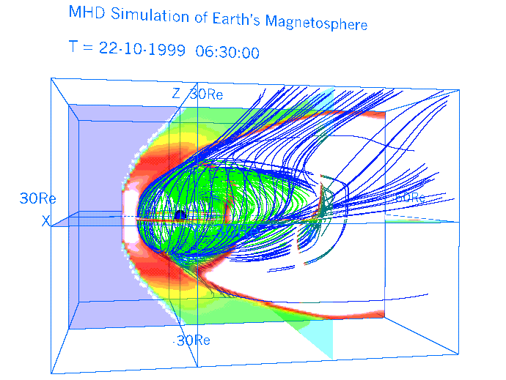

3-4. Three dimensional distribution of the plasma temperature in the whole earth’s magnetosphere drawn by the multiple pixel image planes

The VRML file, which shows the three dimensional distribution of the plasma temperature in the whole earth’s magnetosphere with dawn-dusk asymmetry by the multiple pixel image planes, is made by the three-dimensional MHD simulation data. It is executed by main program: zvrmpxa.f and subroutine package: zvrsuba.f.

Input variable:
tra : Transparency of pixel image plane (0.0 ~ 0.5 : 0.0 means 100% Transparency
0.5 means 50%Transparency )
ipn : Number of planes
icc : Direction of planes (1 : zx plane, 2 : yz plane, 3 : xy plane)

Main using subroutine ( refer to 3-1 ):
pixel1(nx,ny,xb,yb,xl,yl,ipx0,ico,icc,zcc,vmin,vmax,tra,u)

Drawing example: This example shows how to draw the plasma temperature distribution of the earth’s magnetosphere from the result of three-dimensional MHD simulation. It is drawn with multiple pixel image planes by using transparent method.
fig.3-1 : fa410zx.wrl Example by drawing multiple zx planes
(in case of icc=1 and ipn=11)
fig.3-2 : fa410yz.wrl Example by drawing multiple yz planes
(in case of icc=2, ipn=11)
fig.3-3 : fa410xy.wrl Example by drawing multiple xy planes
(in case of icc=3, ipn=11)
fig.3-4 : fa410xyz.wrl a synthesis file with above three files by using “cat”

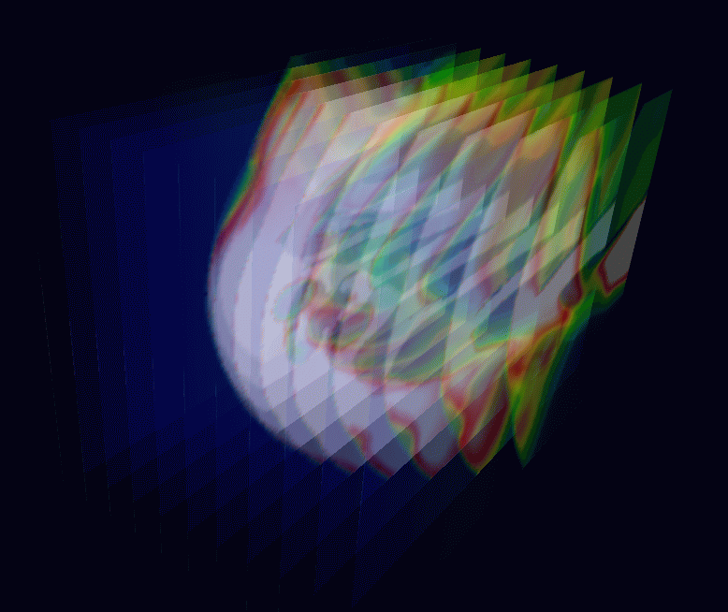
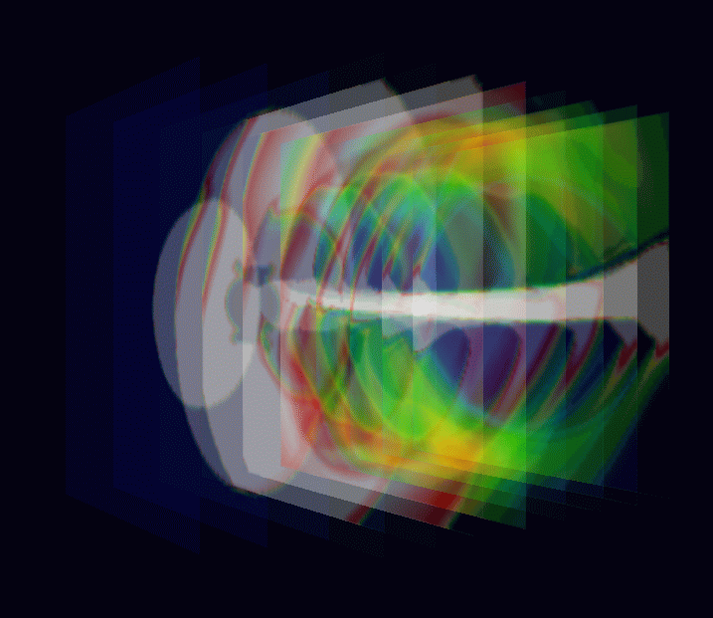

fig.3-1 : fa410zx.gif fig.3-2 : fa410yz.gif
(made from fa410zx.wrl) (made from fa410yz.wrl)
Image of multiple zx planes Image of multiple yz planes

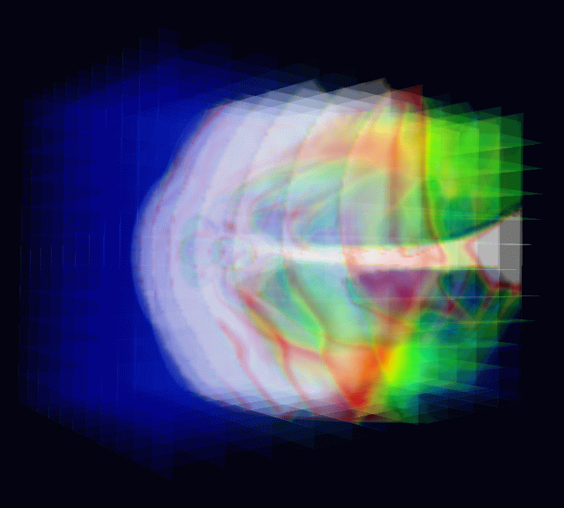
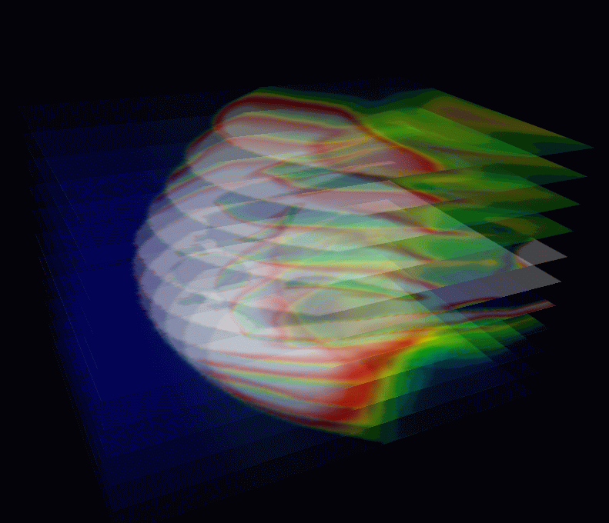

fig.3-3 : fa410xy.gif fig.3-4 : fa410xyz.gif
(made from fa410xy.wrl) (made from fa410xyz.wrl)
Image of multiple xy planes Synthesis image with multiple planes
in three directions

4. 3-Dimensional MHD Simulation of Earth's Magnetosphere
<Example to execute the MHD Code and Graphic programs>

We will demonstrate how to execute the 3-Dimensional magnetohydrodynamic (MHD) Simulation of Earth's Magnetosphere in 1/4 volume and how to use the graphics programs to make PostScript files and VRML files in this section. In the MHD model, MHD and Maxwell's equations are solved in the solar-magnetospheric coordinate system by using modified leap-frog method when the upstream solar wind and interplanetary magnetic field (IMF) boundary conditions are given. Moreover, north-south symmetry and dawn-dusk symmetry are assumed, therefore it is enough to solve 1/4 volume as the simulation box. The main simulation Fortran program, earthb10.f is fully vectorized and can be executed on many kinds of computers. By executing the main MHD simulation code, a simulated binary file is produced as output. When the output binary file is used as input, graphics programs can be executed to make PostScript files and VRML files for three dimensional visualization.

main program : earthb10.f
earthb10.f using modified leap-frog scheme
3D MHD simulation of 1/4 earth's magnetosphere
Cartesian coordinate finite resistivity 45 degree boundary

graphics program to make PostScript files

1. gm150b.f (main) + gsub150.f (subroutine)
noon-midnight meridian and equatorial plots (black and white)
2. gm220b.f (main) + gsub220.f (subroutine)
energy distribution of cross section
3. gm480b.f (main) + gsub480.f (subroutine)
3-dimensional magnetic field lines

3-dimensional graphics program by VRML files
<Virtual Reality Modeling Language>

1. zvrmagb.f (main) + zvrsubbf (subroutine)
3-dimensional magnetic field lines
2. zvrcrob.f (main) + zvrsubb.f (subroutine)
cross sectional pattern by pixel image

<<Summary of parameters in MHD Simulation Code>>

(nx,ny,nz)=(180,60,60) grid number without boundary
nxp=30 parameter to determine earth position
last=1024 number of time steps
iiq0=8 a unit of modified leap-frog scheme
iip0= 32 adjust upstream boundary condition
iis0= 1024 sampling step of data
thx=4.00 parameter to adjust time step
(xl,yl,zl)=(90.5,30.5,30.5)Re length in each direction
hx=xl/float(nx+1)=0.5Re grid interval in x direction
hy=yl/float(ny+1)=0.5Re grid interval in y direction
hz=zl/float(nz+1)=0.5Re grid interval in z direction
t=0.5*hx*thx time interval
t(real)=t*ts real time to one time step advance
=0.5*0.5*4.00*0.937 ts is normalization value in time
=0.937 sec

x=0.5*hx*float(2*i-nx2-1+2*nxp) x position versus grid number
y=0.5*hy*float(2*j-3) y position versus grid number
z=0.5*hz*float(2*k-3) z position versus grid number

where nx2=nx+2, ny2=ny+2 and nz2=nz+2

ro01=5.0E-4 (5/cc) mass density of solar wind
pr01=3.56E-8 pressure of solar wind
vsw=0.044 (300km/s) speed of solar wind
bis=CP(11)=1.5E-4 (5nT) amplitude of IMF

eatt resistivity
rmuu viscosity
eud0 friction or collision term

1-dimensional array variable f(i1)=f(i,j,k,m)

n1=nx+2,n2=n1*(ny+2),n3=n2*(nz+2)
nb=8,nbb=11,n4=n3*nb,n5=n3*nbb

i1=i+n1*(j-1)+n2*(k-1)+n3*(m-1)

m=1 : rho, plasma density
m=2 : Vx
m=3 : Vy
m=4 : Vz
m=5 : P, plasma pressure
m=6 : Bx
m=7 : By
m=8 : Bz

<<execution of main program>>
1. f77 -O earthb10.f
2. a.out &

where file must be defined in open statement like

c open(10,file='earthb10.data',
c 1 access='sequential',form='unformatted')
open(11,file='earthb11.data',
1 access='sequential',form='unformatted')
c

or

1. f77 -o earthb10 -O earthb10.f
2. earthb10 &

<<execution of PostScript graphics program>>

1. f77 -c -O gsub150.f
2. f77 -O gm150b.f gsub150.o
3. a.out > gm150b.ps &
4. gs gm150b.ps
5. lp gm150b.ps

1. f77 -c -O gsub220.f
2. f77 -O gm220b.f gsub220.o
3. a.out > gm220b.ps &

1. f77 -c -O gsub480b.f
2. f77 -O gm480b.f gsub480b.o
3. a.out & : output is written in fort.10

<<execution of VRML graphics program>>

1. f77 -c -O zvrsubb.f
2. f77 -O zvrmagb.f zvrsubb.o
3. a.out & : output is written in fort.10
4. mv fort.10 fort.102

1. f77 -c -O zvrsubb.f
5. f77 -O zvrcrob.f zvrsubb.o
6. a.out & : output is written in fort.10
7. mv fort.10 fort.101
8. cat fort.101 fort.102 > zvrml01.wrl

References:

T. Ogino, A three-dimensional MHD simulation of the interaction of the solar
wind with the earth's magnetosphere: The generation of field-aligned
currents, J. Geophys. Res., 91, 6791-6806 (1986).

T. Ogino, R.J. Walker and M. Ashour-Abdalla, A global magnetohydrodynamic
simulation of the magnetosheath and magnetopause when the interplanetary
magnetic field is northward, IEEE Transactions on Plasma Science,
Vol.20, No.6, 817-828 (1992).

T. Ogino, Two-Dimensional MHD Code, (in Computer Space Plasma Physics),
Ed. by H. Matsumoto and Y. Omura, Terra Scientific Publishing Company,
161-215, 411-467 (1993).

T. Ogino, R.J. Walker and M. Ashour-Abdalla, A global magnetohydrodynamic
simulation of the response of the magnetosphere to a northward turning of
the interplanetary magnetic field, J. Geophys. Res., Vol.99, No.A6,
11,027-11,042 (1994).

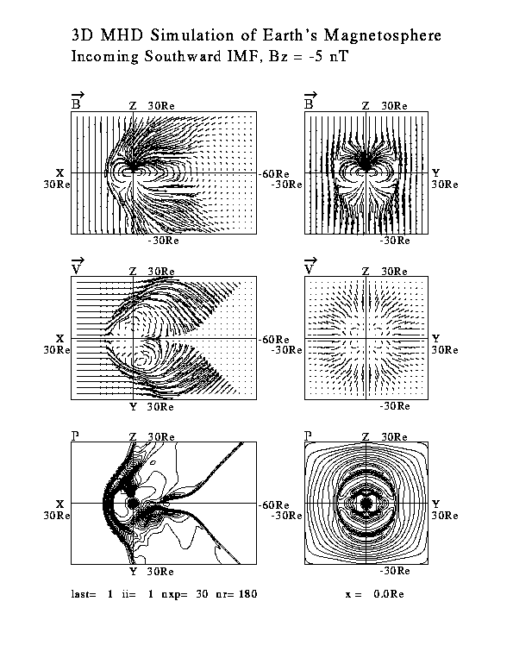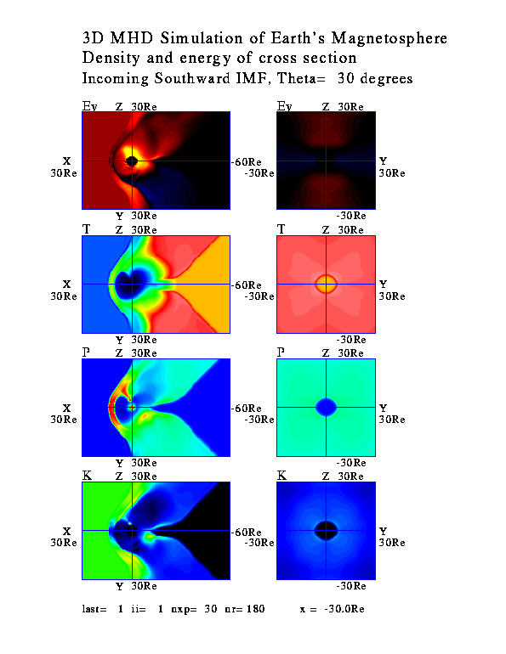
Fig.1. gm150b.gif Fig.2. gm220b.gif
(converted from gm150b.ps) (converted from gm220b.ps)
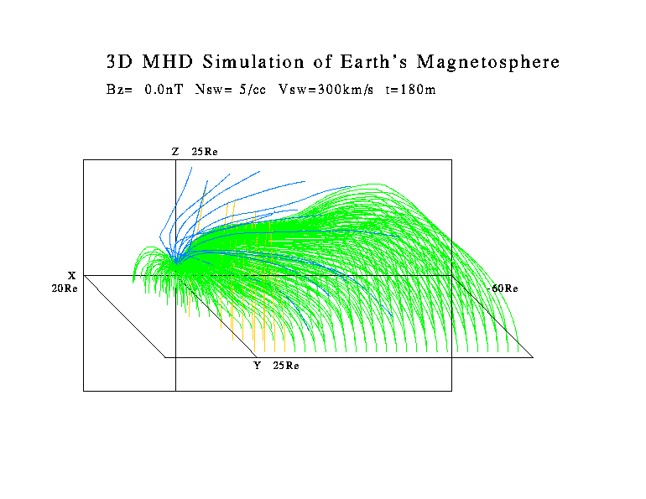
Fig.3. gm480b.gif (converted from gm480b.ps)

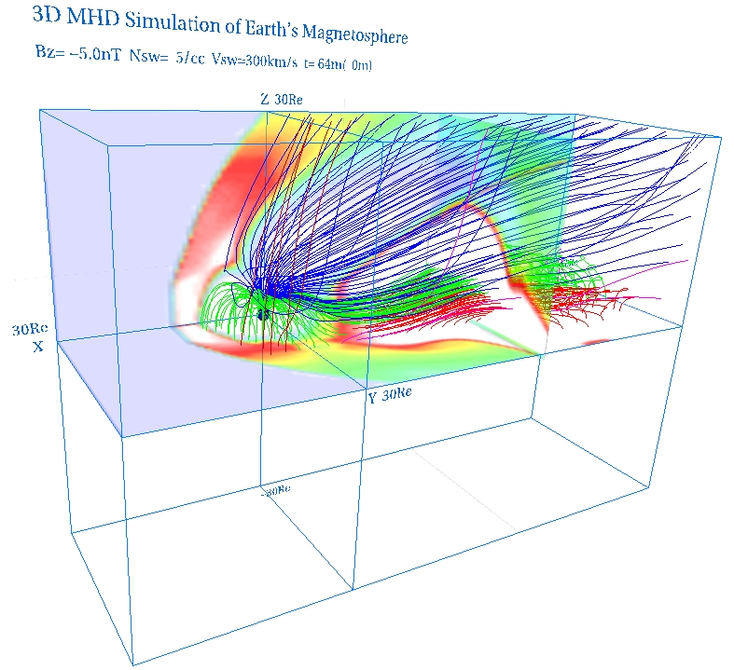
Fig.4. zvrml1b.jpg (made from zvrml1b.wrl)

5. Visualization to Various 3-Dimensional MHD Models of Earth's Magnetosphere (English)

We will show how to use the graphics programs to make VRML files of various 3-Dimensional MHD models of Earth’s Magnetosphere. The output binary files produced by various MHD simulation codes by using modified leap-frog scheme are used as input.

<<execution of VRML graphics program>>

1. f77 -c -O zvrsubb.f
2. f77 -O zvrmagb.f zvrsubb.o

where file must be defined in open statement like
c open(10,file='earthb10.data',
c 1 access='sequential',form='unformatted')
open(11,file='earthb11.data',
1 access='sequential',form='unformatted')
c
3. a.out & : output is written in fort.10
4. mv fort.10 fort.102

1. f77 -c -O zvrsubb.f
5. f77 -O zvrcrob.f zvrsubb.o
6. a.out & : output is written in fort.10
7. mv fort.10 fort.101
8. cat fort.101 fort.102 > zvrml01.wrl

<<Summary of parameters in MHD Simulation Code>>
(nx,ny,nz) = (180,60,60) grid number without boundary
nxp=30 parameter to determine earth position
(xxl,yyl,zzl) = (90.5,30.5,30.5)Re length in each direction
hx=xxl/float(nx+1)=0.5Re grid interval in x direction
hy=yyl/float(ny+1)=0.5Re grid interval in y direction
hz=zzl/float(nz+1)=0.5Re grid interval in z direction

1-dimensional array variable f(i1)=f(i,j,k,m)
i1=i+n1*(j-1)+n2*(k-1)+n3*(m-1)

m=1 : rho, plasma density
m=2 : Vx, x component of velocity
m=3 : Vy, y component of velocity
m=4 : Vz, z component of velocity
m=5 : P, plasma pressure
m=6 : Bx, x component of magnetic field
m=7 : By, y component of magnetic field
m=8 : Bz, z component of magnetic field

5-a. Half volume model of earth’s magnetosphere with IMF By and Bz components

<<example data file used in this section>>
${\vec{B}}_{\text{IMF}}=(B_{y},B_{z})$ gg220410.data
(nx,ny,nz) = (180,60,120)
nxp = 30
time = 410m
$y$${\vec{B}}_{\text{IMF}}=(B_{y},B_{z})$
theta = 30 deg

<<3-dimensional graphics program by VRML files>>
1. 3-dimensional magnetic field lines
zvrmaga.f (main) + zvrsuba.f (subroutine) > fa410m.wrl
2. cross sectional pattern by pixel image
zvrcroa.f (main) + zvrsuba.f (subroutine) > fa410c.wrl
3. cross sectional pattern by velocity vectors
zvrvela.f (main) + zvrsuba.f (subroutine) > fa410v.wrl

a synthesis file with above three files using “cat” > fa410w.wrl

4. 3-dimensional pixel image with multi-planes
zvrmpxa.f (main) + zvrsuba.f (subroutine)
zx planes selected in parameter > fa410zx.wrl
yz planes selected in parameter > fa410yz.wrl
xy planes selected in parameter > fa410xy.wrl
a synthesis file with above three files using “cat” > fa410xyz.wrl

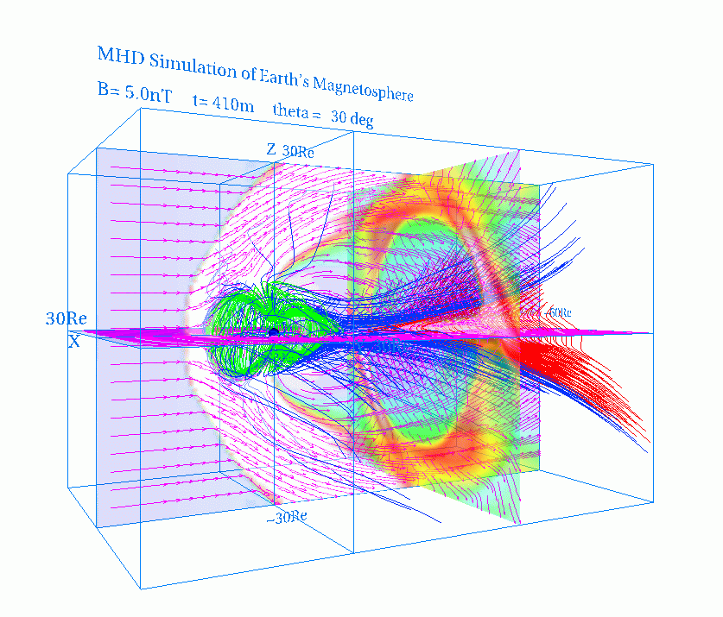

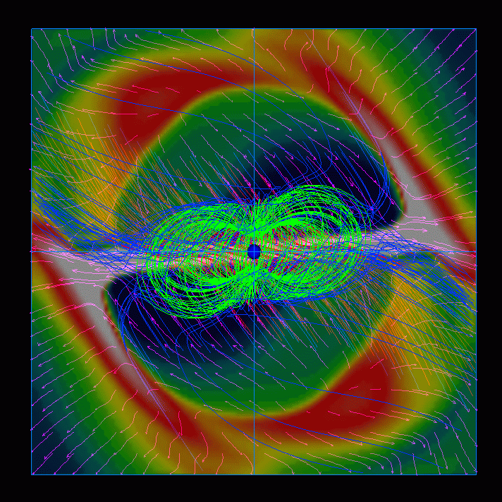

fig.5-1 : fa410w.gif (made from fa410w.wrl) fig.5-2 : fa410s.gif
Whole image of magnetosphere (made from fa410w.wrl)
View from the sun

fig.5-3 : fa410yz.gif (made from fa410yz.wrl) fig.5-4 : fa410xyz.gif (made from fa410xyz.wrl)
Image of multiple yz planes Synthesis image with multiple planes
in three directions

5-b. Quarter volume model of earth’s magnetosphere

<<example data file used in this section>>
ggswb240.data
(nx,ny,nz) = (180,60,60)
nxp = 30
time = 240m
$(\text{By}=0)$$\text{Bz}$ IMF

<<3-dimensional graphics program by VRML files>>
1. 3-dimensional magnetic field lines
zvrmagb.f (main) + zvrsubb.f (subroutine) > fb240m.wrl
2. cross sectional pattern by pixel image
extended pattern to whole volume
zvrcrob.f (main) + zvrsubb.f (subroutine) > fb240c.wrl
quater volume pattern
zvrcrobq.f (main) + zvrsubb.f (subroutine) > fbq240c.wrl
3. cross sectional pattern by velocity vectors
extended pattern to whole volume
zvrvelb.f (main) + zvrsubb.f (subroutine) > fb240v.wrl
quater volume pattern
zvrvelbq.f (main) + zvrsubb.f (subroutine) > fbq240v.wrl

a synthesis file with fb240m.wrl , fb240c.wrl and fb240v.wrl using “cat” > fb240w.wrl
a synthesis file with fb240m.wrl , fbq240c.wrl and fbq240v.wrl using “cat” > fbq240w.wrl

4. 3-dimensional pixel image with multi-planes
zvrmpxb.f (main) + zvrsubb.f (subroutine)
zx planes selected in parameter > fb240zx.wrl
yz planes selected in parameter > fb240yz.wrl
xy planes selected in parameter > fb240xy.wrl
a synthesis file with above three files using “cat” > fb240xyz.wrl

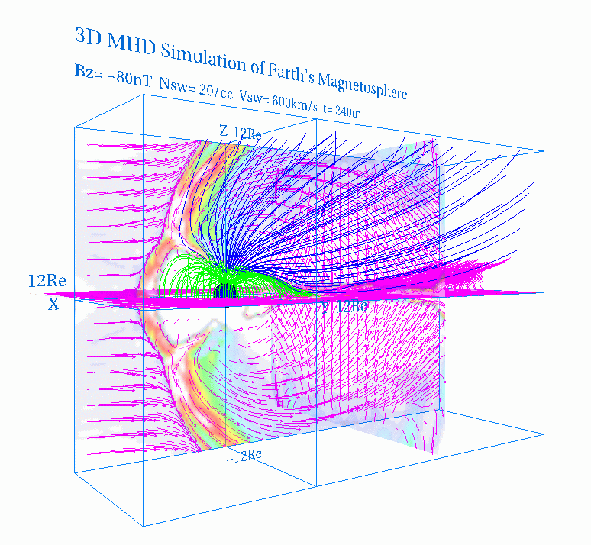

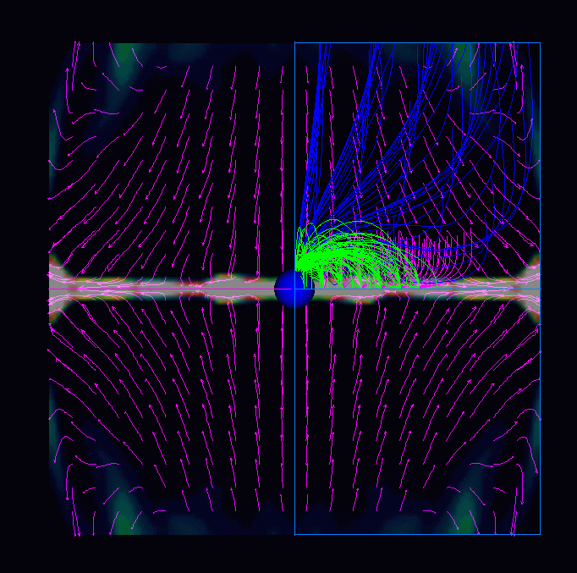

fig.5-5 : fb240w.gif (made from fb240w.wrl) fig.5-6 : fb240s.gif
Whole image of magnetosphere (made from fb240w.wrl)
View from the sun

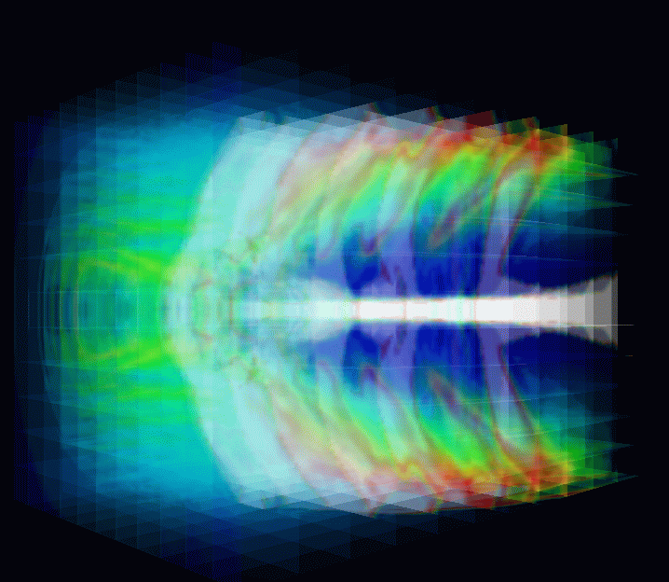
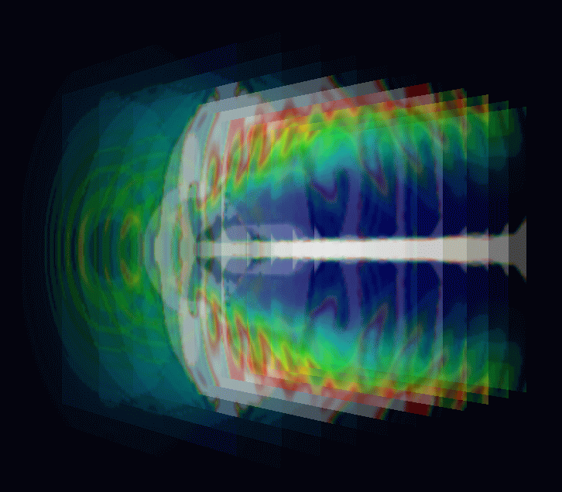

fig.5-7 : fb240yz.gif (made from fb240yz.wrl) fig.5-8 : fb240xyz.gif (made from fb240xyz.wrl)
Image of multiple yz planes Synthesis image with multiple planes
in three directions

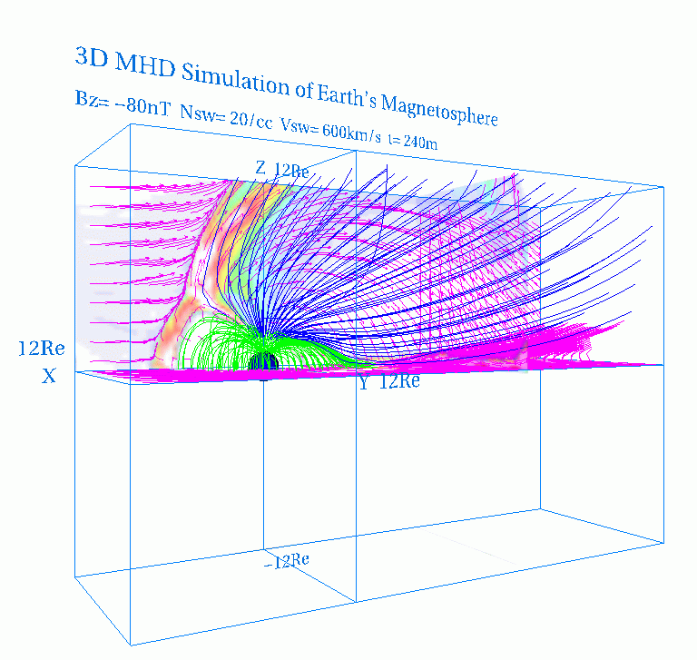

fig.5-9 : fbq240w.gif (made from fbq240w.wrl)
Whole image of magnetosphere

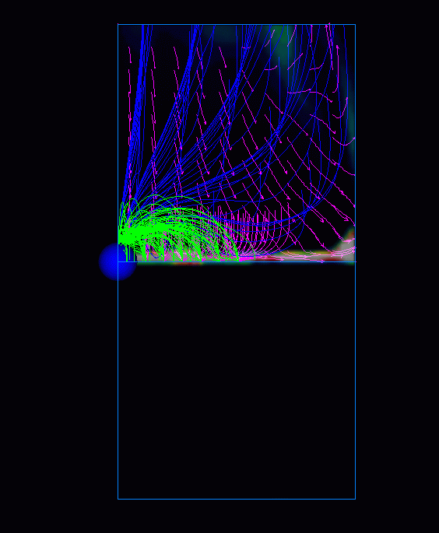

fig.5-10 : fbq240s.gif (made from fbq240w.wrl)
View from the sun

5-c. Half volume model of earth’s magnetosphere with dipole tilt

<<example data file used in this section>>
gcc1a360.data
(nx,ny,nz) = (180,60,120)
nxp = 30
time = 360m
$(\text{By}=0)$$\text{Bz}$ dipole tilt + IMF

<<3-dimensional graphics program by VRML files>>
1. 3-dimensional magnetic field lines
zvrmagc.f (main) + zvrsubc.f (subroutine) > fc360m.wrl
2. cross sectional pattern by pixel image
zvrcroc.f (main) + zvrsubc.f (subroutine) > fc360c.wrl
3. cross sectional pattern by velocity vectors
zvrvelc.f (main) + zvrsubc.f (subroutine) > fc360v.wrl

a synthesis file with above three files using “cat” > fc360w.wrl

4. 3-dimensional pixel image with multi-planes
zvrmpxc.f (main) + zvrsubc.f (subroutine)
zx planes selected in parameter > fc360zx.wrl
yz planes selected in parameter > fc360yz.wrl
xy planes selected in parameter > fc360xy.wrl
a synthesis file with above three files using “cat” > fc360xyz.wrl

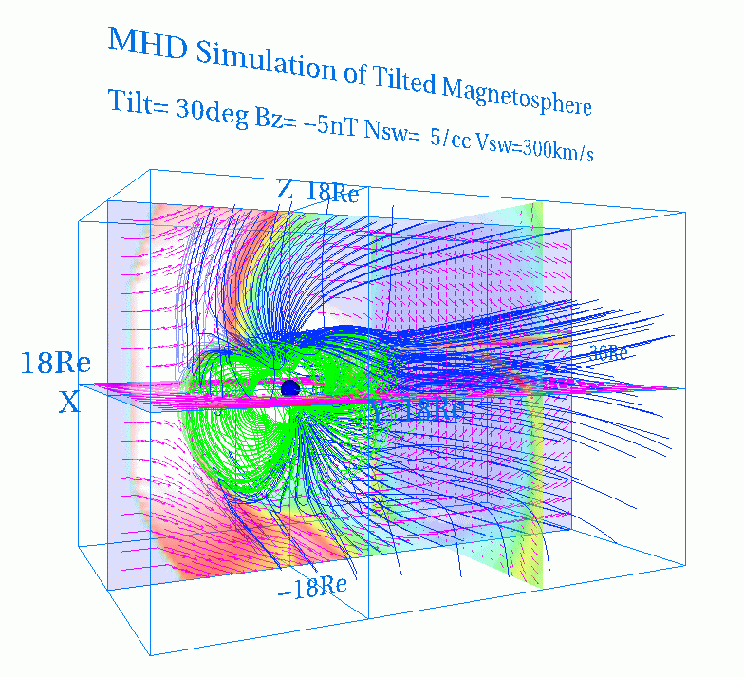

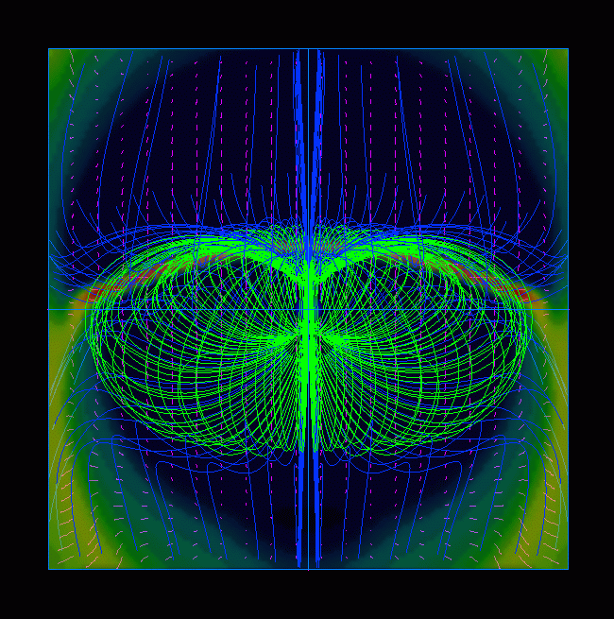

fig.5-11 : fc360w.gif ( made from fc360w.wrl) fig.5-12 : fc360s.gif
Whole image of magnetosphere (made from fc360w.wrl)
View from the sun

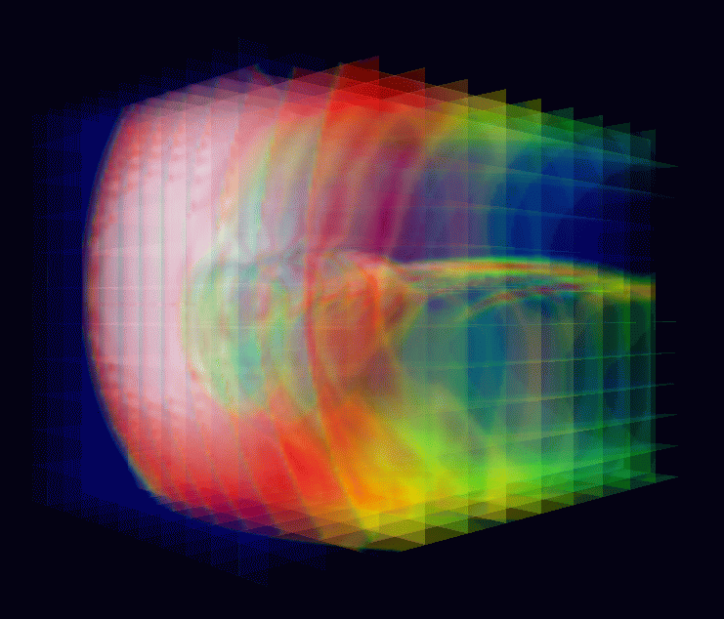
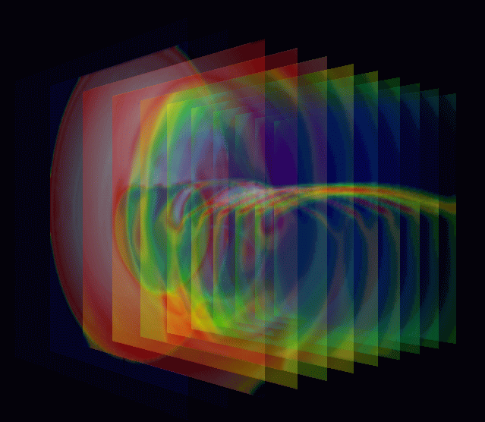

fig.5-13 : fc360yz.gif (made from fc360yz.wrl) fig.5-14 : fc360xyz.gif (made from fc360xyz.wrl)
Image of multiple yz planes Synthesis image with multiple planes
in three directions

5-d. Whole volume model of earth’s magnetosphere

<<example data file used in this section>>
${\vec{B}}_{\text{IMF}}=(B_{y},B_{z})$ gdd1e180.data
(nx,ny,nz) = (180,120,120)
nxp = 30
${\vec{B}}_{\text{IMF}}=(B_{y},B_{z})$ time = 180m
$y$ dipole tilt + IMF
tilt = 30 deg
theta = 45deg

<<3-dimensional graphics program by VRML files>>
1. 3-dimensional magnetic field lines
zvrmagd.f (main) + zvrsubd.f (subroutine) > fde180m.wrl
2. cross sectional pattern by pixel image
zvrcrod.f (main) + zvrsubd.f (subroutine) > fde180c.wrl
3. cross sectional pattern by velocity vectors
zvrveld.f (main) + zvrsubd.f (subroutine) > fde180v.wrl

a synthesis file with above three files using “cat” > fde180w.wrl

4. 3-dimensional pixel image with multi-planes
zvrmpxd.f (main) + zvrsubd.f (subroutine)
zx planes selected in parameter > fde180zx.wrl
yz planes selected in parameter > fde180yz.wrl
xy planes selected in parameter > fde180xy.wrl
a synthesis file with above three files using “cat” > fde180xyz.wrl

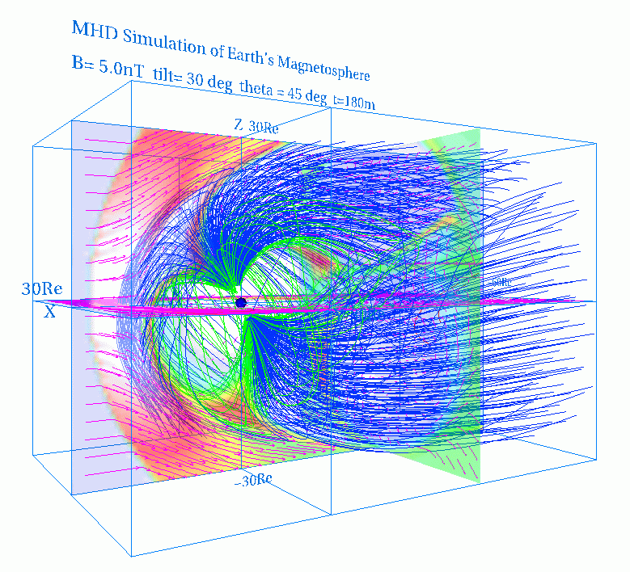

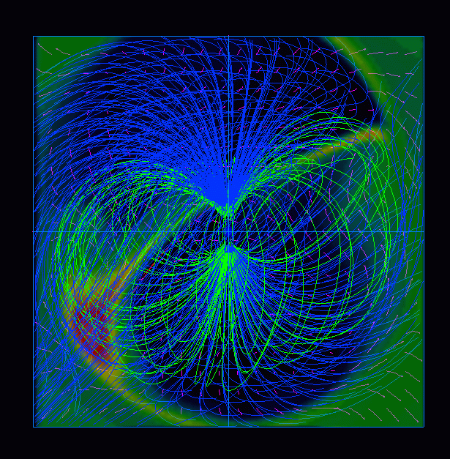

fig.5-15 : fde180w.gif (made from fde180w.wrl) fig.5-16 : fde180s.gif
Whole image of magnetosphere (made from fde180w.wrl)
View from the sun

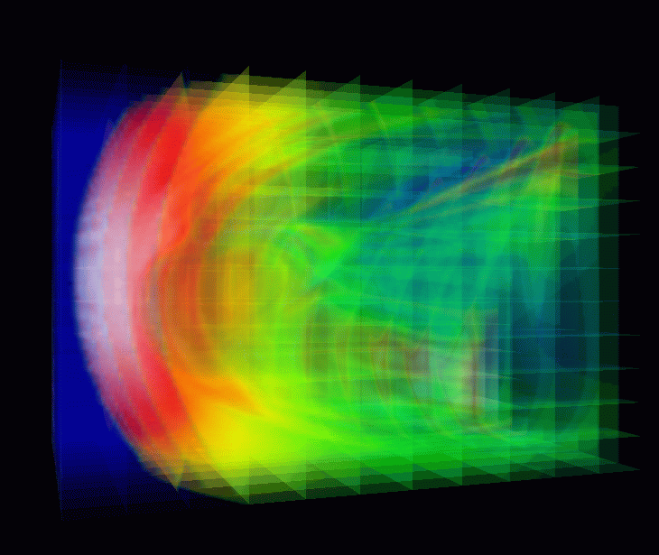
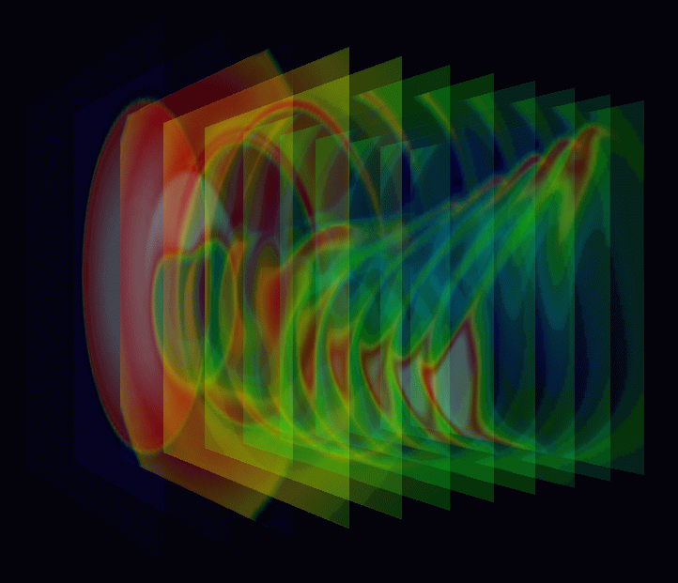

fig.5-17 : fde180yz.gif fig.5-18 : fde180xyz.gif
(made from fde180yz.wrl) (made from fde180xyz.wrl)
Image of multiple yz planes Synthesis image with multiple planes
in three directions

６．Application of VRML to 3-Dimensional MHD Models of Earth's Magnetosphere (English)

6-a. 3-dimensional visualization of earth’s magnetosphere with multiple planes

<<example data file used in this section>>
${\vec{B}}_{\text{IMF}}=(B_{y},B_{z})$ idd1i540.data
(nx,ny,nz) = (268,134,134)
nxp = 30
${\vec{B}}_{\text{IMF}}=(B_{y},B_{z})$ time = 540m
$y$ dipole tilt + IMF
tilt = 30deg
theta = 0deg

<<3-dimensional graphics program by VRML files>>
1. 3-dimensional magnetic field lines
zvrmagd.f (main) + zvrsubd.f (subroutine) > zvrmagdc2.idd1i540.wrl

2. Plasma velocity vectors in cross section
zvrveld.f (main) + zvrsubd.f (subroutine) > zvrveldc.idd1i540.wrl

3. Pixel image of plasma temperate with multiple planes
zvrmpxd.f (main) + zvrsubd.f (subroutine)
zx planes selected in parameter > pxdzx. idd1i540.wrl
yz planes selected in parameter > pxdyz. idd1i540.wrl
xy planes selected in parameter > pxdxy idd1i540.wrl
a synthesis file with above three files using “cat” > pxd4. idd1i540.wrl

4. a synthesis file with above three files using “cat” > pxd4mdc2v.idd1i540.wrl

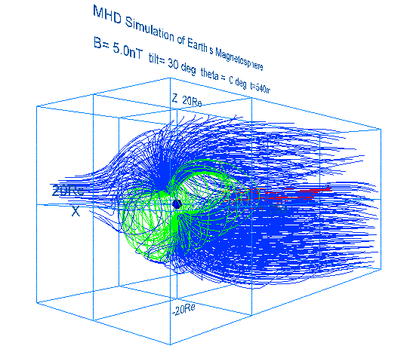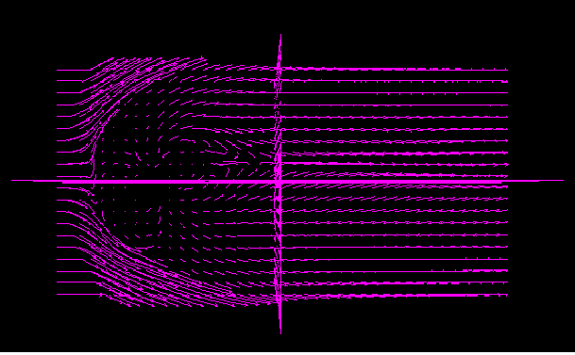

zvrmagdc2.idd1i540.gif zvrveldc.idd1i540.gif
(made from zvrmagdc2.idd1i540.wrl) (made from zvrveldc.idd1i540.wrl)
3-dimensional magnetic field lines Plasma velocity vectors in cross section

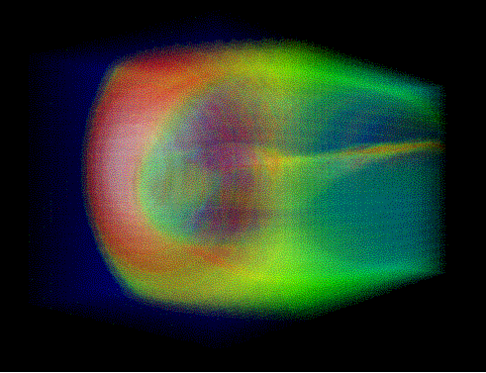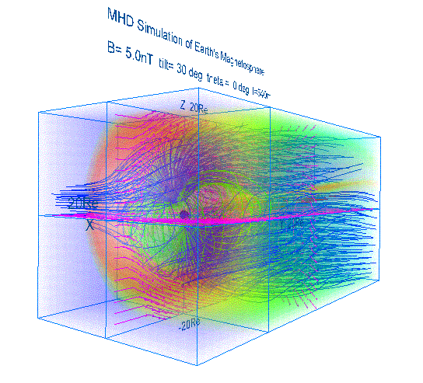

pxd4.idd1i540.gif pxd4mdc2v.idd1i540.gif
(made from pxd4.idd1i540.wrl) (made from pxd4mdc2v.idd1i540.wrl)
Pixel image of plasma temperate Synthesis image with multiple planes
with multiple planes in three directions

6-b. 3-dimensional visualization of earth’s magnetosphere with equivalence planes

<<example data file used in this section>>
idd1n720.data
(nx,ny,nz) = (268, 134, 134)
nxp = 30
time = 720m
dipole tilt + IMF
tilt = 30deg
theta = 90deg

<<3-dimensional graphics program by VRML files>>
1. 3-dimensional magnetic field lines
zvrmagd.f (main) + zvrsubd.f (subroutine) > zvrmagd. idd1n720.wrl

2. Plasma velocity vectors in cross section
zvrveld.f (main) + zvrsubd.f (subroutine) > zvrveld. idd1n720.wrl

3. 3-dimensional visualization with equivalence planes
mcubvrm.f (main) + mcubsub.f (subroutine) > mcub.idd1n720.wrl

4. a synthesis file with above three files using “cat” > mcubmagdv.idd1n720.wrl

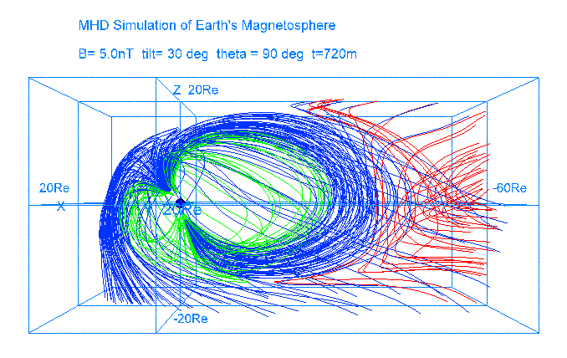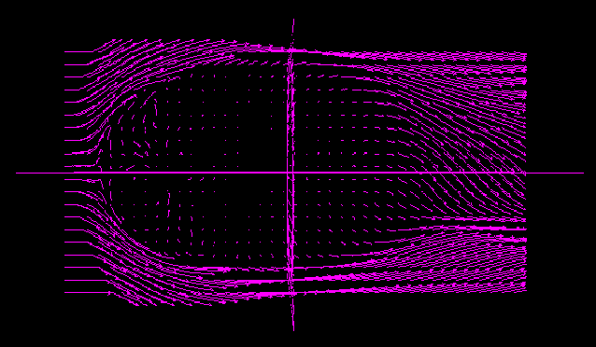

zvrmagdc2.idd1n720.gif zvrveldc.idd1n720.gif
(made from zvrmagdc2.idd1n720.wrl) (made from zvrveldc.idd1n720.wrl)
3-dimensional magnetic field lines Plasma velocity vectors in cross section

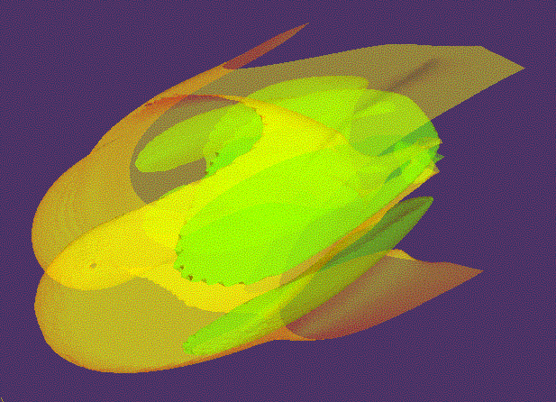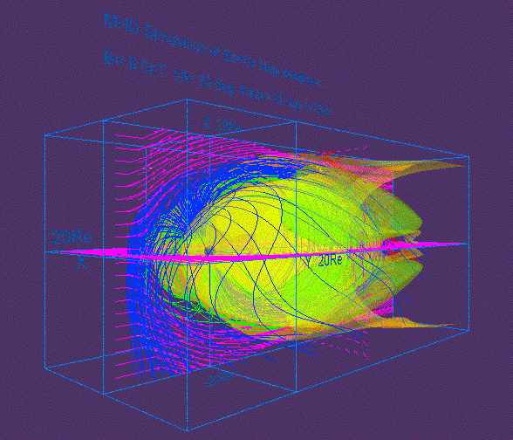

mcub.idd1n720.gif mcubdc2v.idd1n720.gif
(made from mcub.idd1n720.wrl ) (made from mcubmagdv.idd1n720.wrl )
3-dimensional visualization Synthesis image with equivalence planes
with equivalence planes in three directions

6-c. Cropping of 3-dimensional data

main program mbikxyz.f

Input variable :
nx : Data number of the x direction
ny : Data number of the y direction
nz : Data number of the z direction
x0 : The x coordinate of the origin
y0 : The y coordinate of the origin
z0 : The z coordinate of the origin
mb : The number of cropping

Description : This program produce a reduced array, fb(jx,jy,jz) from the original away, fa(ix,iy,iz), where mb is the number of cropping.

ix = 1+mb*(jx-1)
iy = 1+mb*(iy-1)
iz = 1+mb*(iz-1)

References

VRML2.0 3D Cyber Space Language, by Kenjiro Miura, Asakura-syoten, 1996

Web3D Graphics, by Tetsuo Hirouchi, Piason Education, 2001

The VRML 2.0 Handbook, by Jed Hartman and Josie Wernecke, Silicon Graphic, Inc,
Addison-Wesley Publishing Co., 1996

The Annotated VRML 2.0 Reference Manual, by Rikk Carey and Gavin Bell,
Addison-Wesley Publishers Japan, 1998

PostScript Reference Manual Second Edition, by Adobe Systems, ASCII Corporation, 1995

PostScript by Example, by H. McGilton and M. Campione,
Addison-Wesley Publishing Co., 1992

Fortran program and image file list
1. Fundamental example (1)
No. | Contents | Fortran Program | VRML file | gif file
 | Subroutine package | pk1subrtn.f
1 | Cube | box1.f | box1.wrl | box1.gif
2 | Rectangular parallelepiped | box2.f | box2.wrl | box2.gif
3 | Trigonal pyramid | cone1.f | cone1.wrl | cone1.gif
4 | Column | cylinder1.f | cylinder1.wrl | cylinder1.gif
5 | Sphere | sphere1.f | sphere1.wrl | sphere1.gif
6 | Background color | backgrd4.f | backgrd4.wrl | backgrd4.gif
7 | Character string | text1.f | text1.wrl | text1.gif
8 | Polygonal line : monochrome | lineset1.f | lineset1.wrl | lineset1.gif
9 | Polygonal line : gradation | lineset2.f | lineset2.wrl | lineset2.gif
10 | Dotted line : monochrome | pointset1.f | pointset1.wrl | pointset1.gif
11 | Dotted line : gradation | pointset2.f | pointset2.wrl | pointset2.gif
12 | Arrow with the thickness | arrow2.f | arrow2.wrl | arrow2.gif
13 | Curve with the thickness | linemesh1.f | linemesh1.wrl | linemesh1.gif
14 | Plane (1) : Monochromatic triangular mesh | mesh1.f | mesh1.wrl | mesh1.gif
15 | Plane (2) : Triangular belt | triangb1.f | triangb1.wrl | triangb1.gif
16 | Plane (3) : Polychrome triangular mesh | triangm1.f | triangm1.wrl | triangm1.gif
17 | Solid : It is composed of the triangular mesh | defusem1.f | defusem1.wrl | defusem1.gif
18 | Texture mapping | image1.f | image1.wrl | image1.gif
19 | The complicated curved surface  : Triangular mesh | ebmesh3d.f | ebmesh3d.wrl | ebmesh3d.gif

2. Fundamental example (2)
No. | Contents | Fortran Program | VRML file | gif file | jpg file | rgb file
 | Subroutine package | zvrsuba.f
1 | Character | msymbol.f | msymbol.wrl | msymbol.gif
2 | Point | mpoint.f | mpoint.wrl | mpoint.gif
3 | Line | mline.f | mline.wrl | mline.gif
4 | Triangular mesh | mtriangm.f | mtriangm.wrl | mtriangm.gif | mtriangm.jpg | mtriangm.rgb
5 | Pixel image | mzpt03.f | mzpt03.wrl | mzpt03.gif | mzpt03.jpg | mzpt03.rgb
6 | Frame and pixel image and character | mpix015.f | mpix015.wrl | mpix015.gif | mpix015.jpg | mpix015.rgb
7 | Equivalence plane | mcube301.f | mcube301.wrl | mcube301.gif | mcube301.jpg | mcube301.rgb
8 | Outer magnetosphere by 3-dimensional lattice | outline3d.f | outline3d.wrl | outline3d.gif | outline3d.jpg
9 | Inner magnetosphere by 3-dimensional lattice | inline3d.f | inline3d.wrl | inline3d.gif | inline3d.jpg
10 | Ionosphere by 3-dimensional lattice | denline3d.f | denline3d.wrl | denline3d.gif | denline3d.jpg

3. Application to the MHD simulation
No. | Contents | Fortran Program | VRML file | gif file
 | Subroutine package | zvrsuba.f
1 | Sectional views such as plasma temperature of the earth's magnetosphere are drew by the pixel image  - The pixel image using maximum value and minimum value | zvrcroa.f | zvrcroa.wrl | zvrcroa.gif
2 | Three-dimensional structure of the earth's magnetosphere  - The decision by beforehand describing line of magnetic force  - Three-dimensional line of magnetic force starting from polar region  - Three-dimensional line of magnetic force starting from equatorial plane  - The test of the boundary in the closed region with that it opens | zvrmaga.f | zvrmaga.wrl | zvrmaga.gif
3 | The synthesis of the three-dimensional image of pixel image and line of magnetic force |  | zvr01.wrl | zvr01.gif
 | Subroutine package | zvrsuba.f
4 | Three dimensional distribution of the plasma temperature in the whole earth’s magnetosphere drawn by the multiple pixel image planes | zvrmpxa.f | fa410zx.wrl  fa410yz.wrl  fa410xy.wrl  fa410xyz.wrl | fa410zx.gif  fa410yz.gif  fa410xy.gif  fa410xyz.gif

4.3-Dimensional MHD Simulation of Earth's Magnetosphere
(Example to execute the MHD Code and Graphic programs)
No. | Contents | Fortran Main Program | Subroutine Package | PostScript file | VRML file  or gif file
3D MHD simulation code of 1/4 earth's magnetosphere |  | earthb10.f
Graphics program to make PostScript files
1 | noon-midnight meridian and equatorial plots  (black and white) | gm150b.f | gsub150.f | gm150b.ps | gm150b.gif
2 | energy distribution of cross section | gm220b.f | gsub220.f | gm220b.ps | gm220b.gif
3 | 3-dimensional magnetic field lines | gm480b.f | gsub480.f | gsub480.ps | gsub480.gif
3-dimensional graphics program by VRML files (Virtual Reality Modeling Language)
1 | 3-dimensional magnetic field lines | zvrmagb.f | zvrsubb.f |  | zvrml1b.wrl  zvrml1b.jpg
2 | cross sectional pattern by pixel image | zvrcrob.f | zvrsubb.f |  | zvrml1b.wrl  zvrml1b.jpg

5.Visualization to Various 3-dimensional MHD Models of Earth’s Magnetosphere
5-a. Half volume model of earth’s magnetosphere with IMF By and Bz components
No. | Contents | Fortran Main Program | VRML file | gif file
 | Subroutine Package | zvrsuba.f
1 | 3-dimensional magnetic field lines | zvrmaga.f | fa410w.wrl | fa410w.gif  fa410s.gif
2 | cross sectional pattern by pixel image | zvrcroa.f | fa410w.wrl | fa410w.gif  fa410s.gif
3 | cross sectional pattern by velocity vectors | zvrvela.f | fa410w.wrl | fa410w.gif  fa410s.gif
4 | 3-dimensional pixel image with multi-planes | zvrmpxa.f | fa410xyz.wrl  fa410yz.wrl | fa410xyz.gif  fa410yz.gif

5-b. Quarter volume model of earth’s magnetosphere
No. | Contents | Fortran Main Program | VRML file | gif file
 | Subroutine Package | zvrsubb.f
1 | 3-dimensional magnetic field lines | zvrmagb.f | fb240w.wrl  fbq240w.wrl | fb240w.gif  fb240s.gif  fbq240w.gif  fbq240s.gif
2 | cross sectional pattern by pixel image | zvrcrob.f  zvrcrobq.f | fb240w.wrl  fbq240w.wrl | fb240w.gif  fb240s.gif  fbq240w.gif  fbq240s.gif
3 | cross sectional pattern by velocity vectors | zvrvelb.f  zvrvelbq.f | fb240w.wrl  fbq240w.wrl | fb240w.gif  fb240s.gif  fbq240w.gif  fbq240s.gif
4 | 3-dimensional pixel image with multi-planes | zvrmpxb.f | fb240xyz.wrl  fb240yz.wrl | fb240xyz.gif  fb240yz.gif

5-c. Half volume model of earth’s magnetosphere with dipole tilt
No. | Contents | Fortran Main Program | VRML file | gif file
 | Subroutine Package | zvrsubc.f
1 | 3-dimensional magnetic field lines | zvrmagc.f | fc360w.wrl | fc360w.gif  fc360s.gif
2 | cross sectional pattern by pixel image | zvrcroc.f | fc360w.wrl | fc360w.gif  fc360s.gif
3 | cross sectional pattern by velocity vectors | zvrvelc.f | fc360w.wrl | fc360w.gif  fc360s.gif
4 | 3-dimensional pixel image with multi-planes | zvrmpxc.f | fc360xyz.wrl  fc360yz.wrl | fc360xyz.gif  fc360yz.gif

5-d. Whole volume model of earth’s magnetosphere
No. | Contents | Fortran Main Program | VRML file | gif file
 | Subroutine Package | zvrsubd.f
1 | 3-dimensional magnetic field lines | zvrmagd.f | fde180w.wrl | fde180w.gif  fde180s.gif
2 | cross sectional pattern by pixel image | zvrcrod.f | fde180w.wrl | fde180w.gif  fde180s.gif
3 | cross sectional pattern by velocity vectors | zvrveld.f | fde180w.wrl | fde180w.gif  fde180s.gif
4 | 3-dimensional pixel image with multi-planes | zvrmpxd.f | fde180xyz.wrl  fde180yz.wrl | fde180xyz.gif  fde180yz.gif

6.Application of VRML to 3-Dimensional MHD Models of Earth's Magnetosphere
6-a. 3-dimensional visualization of earth’s magnetosphere with multiple planes
No. | Contents | Fortran  Main Program | VRML file | gif file
 | Subroutine Package | zvrsubd.f
1 | 3-dimensional magnetic field lines | zvrmagd.f | zvrmagdc2.idd1i540.wrl | zvrmagdc2.idd1i540.gif
2 | Plasma velocity vectors in cross section | zvrveld.f | zvrveldc.idd1i540.wrl | zvrveldc.idd1i540.gif
3 | Pixel image of plasma temperate with multiple planes | zvrmpxdc5.f | pxd4.idd1i540.wrl | pxd4.idd1i540.gif
4 | Synthesis image with multiple planes in three directions |  | pxd4mdc2v.idd1i540.wrl | pxd4mdc2v.idd1i540.gif

6-b. 3-dimensional visualization of earth’s magnetosphere with equivalence planes
No. | Contents | Fortran  Main Program | Subroutine Program | VRML file
1 | 3-dimensional magnetic field lines | zvrmagd.f | zvrsubd.f | zvrmagdc2.idd1n720.gif
2 | Plasma velocity vectors in cross section | zvrveld.f | zvrsubd.f | zvrveldc.idd1n720.gif
3 | 3-dimensional visualization with equivalence planes | mcubvrm.f | mcubsub.f | mcub.idd1n720.gif
4 | Synthesis image with multiple planes in three directions |  |  | mcubdc2v.idd1n720.gif

6-c. Cropping of 3-dimensional data
No. | Contents | Fortran  Main Program | Subroutine Program | VRML file
1 | cropping of 3-dimensional data | mbikxyz.f

Acknowledgements:
Individual subroutines in this manual, "How to Use VRML" have been developed by the project team of "Development and standardization of the visualization tool by the VRML" of the Solar-Terrestrial Environment Laboratory, Nagoya University from 1997, and it was arranged by the JST Computer Science and Technology Promotion Program, "The Development of Space Simulation Net-Laboratory System" as this manual.
The computer simulation was performed on Fujitsu VPP5000-16PE in the Computer Center of Nagoya University.

Project team of "Development and standardization of the visualization tool by the VRML"
Tatsuki Ogino ( Leader )
Maki Nakao
Yuka Kadowaki
Minako Suganuma
Manami Inayoshi
Koichi Ota

March, 2003
Solar-Terrestrial Environment Laboratory, Nagoya University
3-13 Honohara, Toyokawa, Aichi 442-8507, Japan
TEL:+81-533-89-5207 FAX:+81-533-89-5090
E-mail:ogino@stelab.nagoya-u.ac.jp



